- Home

- All Journals

- International Journal of Phytoremediation

- List of Issues

- Volume 24, Issue 4

- Decaffeination of wastewater using activ ....

Advanced search
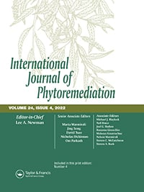

International Journal of Phytoremediation

Volume 24, 2022 - Issue 4

Decaffeination of wastewater using activated carbon produced from velvet tamarind-pericarp (Dialium Guineense)
Babalola Aisosa Oni
,
Samuel Eshorame Sanni
,
Samuel Olatunde Dahunsi
&
Bisike Chidiebere Egere
Pages 394-408 | Published online: 20 Jul 2021
- Cite this article

- https://doi.org/10.1080/15226514.2021.1950118

- CrossMark

- Full Article

- Figures & data

- References

- Supplemental

- Citations

- Metrics

- Reprints & Permissions

- Read this article

Abstract
Adsorption of caffeine from an aqueous solution was carried out using Velvet Tamarind-Pericarp, activated with H₃PO₄. The adsorbent was characterized using a scanning-electron microscope and the Brunauer-Emmett-Teller. Parameters such as activating agent concentration (80 wt.% in 100 mL solution), initial caffeine concentration of 5−40 g/L, pH of 0−14, and residence time 0−90 minutes, were investigated. Improved adsorptive capacities were seen at increased acid concentrations, with the highest removal rate obtained at a pH of 6. The highest residence time and adsorbent concentrations were obtained at 40 min and 10 g/L. The surface adsorption of the adsorbent obeyed the Langmuir Isotherm, while the regression coefficients conformed to the pseudo-second-order kinetic model for the remediation of caffeine with DG-AC. The highest amount of caffeine removed per gram DG is 72.60 mg.g⁻¹. From the thermodynamic study, the caffeine adsorption was feasible, spontaneous, entropy-driven, and endothermic. These data show that the use of DG-AC can be a good alternative to other expensive methods for caffeine remediation. The Pseudo – first/second-order kinetic results gave R² values of 0.95 and 0.99, other parameters such as entropy (Δ�°) and enthalpy (Δ�°) are 0.06 (��molK) and (19.21) (��molK).
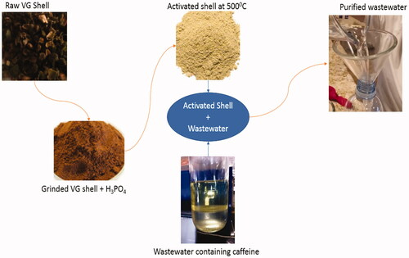
Novelty statement The novelty of the work is that the adsorption of caffeine from an aqueous solution/pharmaceutical wastewater was carried out on activated carbon produced from African velvet tamarind (pericarp) and phosphoric acid as activating agent.
Keywords:
- Caffeine
- velvet tamarind
- wastewater
- adsorption
- activated carbon
- contaminantsCited by
1
Caffeine in Coffee: Its Removal. Why and How?
K. Ramalakshmi et al.
Critical Reviews in Food Science and Nutrition
Published online: 3 Jun 2010

