Contribution of positron emission tomography in pleural disease

B. Duysinxª, J.-L. Corhayª, M.-P. Larock^{b}, N. Withofs^{b}, T. Buryª, R. Hustinx^{b}, R. Louisª
ª Chest Clinic, Sart-Titman University Hospital B35, 4000 Liège, Belgium
^{b} Nuclear Medicine Department, Sart-Tilman University Hospital B35, 4000 Liège, Belgium

Summary
Introduction. - Positron emission tomography (PET) now plays a clear role in oncology, especially in chest tumours. We discuss the value of metabolic imaging in characterising pleural pathology in the light of our own experience and review the literature.
Background. - PET is particularly useful in characterising malignant pleural pathologies and is a factor of prognosis in mesothelioma. Metabolic imaging also provides clinical information for staging lung cancer, in researching the primary tumour in metastatic pleurisy and in monitoring chronic or recurrent pleural pathologies.
Conclusions. - PET should therefore be considered as a useful tool in the diagnosis of liquid or solid pleural pathologies.
Keywords: Positron emission tomography ; Pleurisy ; Pleural mesothelioma ; Pleural metastasis ; Lung cancer

Introduction
Pleural disorders occur frequently in pulmonology and include a variety of inflammatory, infectious and industrial diseases and also malignancies. One of the most common presentations is pleural thickening or pleurisy. Researching the aetiology of pleural disease involves a very broad range of differential diagnoses, sometimes complicated by the fact that there are no criteria that are truly specific to malignancies on the conventional imaging exploration techniques such as plain radiographs, CT-scans and MRI [1,2]. It is true that the chemistry, bacteriology and cytology of the pleural fluid can make a significant contribution to the diagnosis [3,4]. However, although thoracocentesis is an essential examination, its sensitivity in the diagnosis of pleurisy caused by tuberculosis or malignancies is only 28 and 62% respectively [5]. In both these aetiologies the sensitivity of pleural needle aspiration biopsy, performed blind, is only 51 and 44% [5-7]. Thoracoscopy is therefore often essential and in some cases unavoidable to research an accurate aetiological diagnosis and remains the gold standard for exploring pleural disorders. Its diagnostic yield is above 95% [5], although it is an invasive procedure and can sometimes be difficult to perform, especially in elderly patients whose cardiopulmonary status is poor. Pleuroscopy can also be technically complicated, particularly when there are multiple adhesions in the pleura or in cases of isolated pleural thickening; in some cases it can even be contraindicated (coagulation disorders, serious heart disorders, patient with only one lung...) [8]. It also requires a medical team that is highly skilled in the technique and lastly, pleurisies that are potentially malignant tend to recur and repeated thorascopic examinations can be an extra burden for the patient. Although pleural metastases usually arise from lung (41%) and breast (18%), cancer, researching the primary tumour can sometimes be a long, complicated process, entailing numerous complementary examinations that are often costly and do not always identify the primary disease. In over 10% of pleural malignancies the primary tumour is never found [9-11].
18 fluorodeoxyglucose (18FDG) labelled metabolic imaging by positron emission tomography (PET) is frequently used in oncology today, especially in pulmonary tumours [12-15]. It has many indications: characterising a single pulmonary nodule [16], mediastinal staging [17,18] and it can also be useful in the screening and surveillance of extrathoracic non small-cell lung carcinoma (NSCLC) metastases [19,20], and for monitoring their treatment [21]. Because pleural diseases are difficult to diagnose and the conventional exploration techniques are not very effective, 18FDG labelled metabolic PET imaging has gradually demonstrated its value in contributing clinically useful input to the decision-making algorithm for exploring these disorders [22]; PET now has an acknowledged role to play, especially in assessing isolated lymphocyte-rich exudative disorders or when the clinical picture alone does not provide an explanation.
The contribution of metabolic imaging in identifying malignant pleural diseases
Several studies [23-32] give details of the performance of PET in the differential diagnosis of primary or secondary pleural malignancies and benign pleurisy. The distinction between benign and malignant disorders is based on a visual analysis made by a skilled physician in these studies. The sensitivity is excellent (89-100%), and the specificity is acceptable (67-100%), with a negative predictive value between 67 and 100% and an accuracy of diagnosis above 80%, which is higher than the cytology results for thoracocentesis (Table 1). Three of these studies were carried out on a significant number of patients [24,26,29] and are well worth closer scrutiny.

Table 1 Data in the literature giving details of the performance of PET in the differential diagnosis between malignant and benign pleural disease.
 | n | Histology | Sensitivity (%) | Specificity  (%) | Positive predictive  (%) | value (%) | Accuracy (%)
Benard et al. [23] | 28 | MPM and MP | 91 | 100 | - | - | 92
Duysinx et al. [24] | 98 | MPM and MP | 96.8 | 88 | 94 | 94 | -
Kramer et al. [25] | 32 | MPM and MP | 95 | 92 | 95 | 92 | 94
Schaffler et al. [26] | 92 | MP in NSCLC | 100 | 71 | 63 | 100 | 80
Carretta et al. [27] | 14 | MPM and MP | 92 | - | - | - | 92
Erasmus et al. [28] | 25 | MP in NSCLC | 95 | 67 | 95 | 67 | 92
Gupta et al. [29] | 35 | MP in NSCLC | 88.8 | 94.1 | 94 | 88 | 91.4
Bury et al. [30] | 25 | MP | 100 | 78 | 89 | 100 | -
Toaff et al. [31] | 31 | MP | 95 | 80 | 91 | 89 | 90
Balagova et al. [32] | 16 | MPM and MP | 100 | - | - | - | -
MPM: Malignant pleural mesothelioma; MP: Metastatic pleurisy, whatever the primary tumour site; MP in NSCLC: Metastatic pleurisy in non small-cell bronchopulmonary carcinoma.

Our team published a prospective study [24] on 98 patients (67 males and 31 females, mean age 60.9 years) who presented with a pleural disease for which no precise aetiology had been confirmed after a chest x-ray and thoracocentesis. Each of these patients had PET combined with a conventional CT-scan before any invasive exploration. In a secondary stage the final histological diagnosis was made by pleural needle aspiration biopsy (n = 17), pleuroscopy (n = 62), or surgical biopsy by thoracotomy (n = 5). In 14 patients, the diagnosis was based on radiological and clinical follow-up of the pleural disorder alone. In 67 cases the pleural disorder presented as an isolated fluid effusion, as a thickening of the pleura in 12 cases and as a combination of both anomalies in 19 cases. For the 35 benign pleural disorders diagnosed (12 cases of parapneumonia, three of tuberculosis, eight inflammatory, six asbestos-related and three post-radiation disorders, three benign tumours), metabolic imaging identified 31 of the benign pleural disorders correctly with no significant increase in pleural uptake. The four false positives were two cases of pleural effusion due to parapneumonia, one case of tuberculous pleurisy and one case of uraemia-related pleurisy. All the cases of benign asbestos-related and post-radiation pleurisy were correctly classified by PET. In the 63 cases of malignant pleural disease only two did not show an increased uptake of the tracer in the pleura (a « low-grade » lymphoma and a metastasis of a prostate neoplasm). All the cases of metastatic pleurisy of pulmonary malignancies and mesothelioma featured increased FDG uptake in the pleura. On the basis of these results we were able to report a sensitivity of 97%, a specificity of 88%, and negative and positive predictive values of 94% and 94% respectively. Our study confirmed previous data published by Schaffler et al. Their retrospective study [26] included 92 patients with NSCLC who presented with a pleural anomaly. The authors reported three CT-scan categories of pleural involvement:
• pleurisy with destructive bone lesions of the rib cage adjacent to a pleural mass, which was considered to be malignant;
• a pleural lesion was considered to be benign if the density of the pleurisy was below 10 HU, and there were no pathological fractures of the ribs;
• a CT scan anomaly was considered as non-specific if the density of the pleurisy was above 10 HU and/or if there was a solid pleural anomaly with no destructive bone lesions.
The final diagnosis was obtained by ultrasound-guided thoracocentesis or biopsy or video-assisted surgery if the cytology was negative and confirmed 30 cases of malignant pleurisy and 62 benign cases. On conventional imaging, using the criteria described above, 29% of the pleural pathologies were considered to be benign on the CT scan and 71% were not interpretable. PET identified 30 pleural malignancies correctly versus only 44 of the 62 benign pleural disorders; three fractured ribs and 15 cases of empyema were false positives. These authors once again reported that PET was 100% sensitive in identifying pleural malignancies with a specificity of 71%. Once again the negative predictive value was high (100%).
Lastly, Gupta et al. [29] reported the value of PET in screening pleurisy caused by pleural metastases in patients with proven lung cancer and pleural anomalies suspected to be malignant on the thoracic CT-scan (pleural nodules, pleural thickening greater than one centimetre, irregular thickening of the pleura, or thickening associated with pleural effusion). The final diagnosis showed 18 cases of malignant and 17cases of benign disease. On the PET scan, 18 of the pleural disorders showed a high FDG uptake and 16 were true positives. Sixteen out of the 17 benign pleural disorders were negative in terms of FDG uptake. The sensitivity, specificity and negative predictive value of metabolic imaging were respectively 89%, 94% and 89%.
In the light of these results, we feel that PET metabolic imaging is clearly helpful in distinguishing benign pleural diseases from malignancies. It could be especially useful in a number of difficult settings in chest oncology because metastatic pleurisy caused by lung cancer and mesothelioma can be discriminated on metabolic imaging (Fig. 1). In view of its excellent negative predictive value PET can be particularly helpful in identifying malignant pleural disease when there is no increase in FDG uptake in the pleura. The absence of pleural hypermetabolism after radiotherapy also contributes information that can be useful in the restaging, treatment and follow-up of NSCLC. Although PET should not be seen as a replacement for pleuroscopy there is no doubt that it is now part of the diagnostic process in pleural disease; it can also be a way of avoiding an escalation of invasive explorations, especially if pleuroscopy seems risky. In the case of isolated thickening of the pleural tissue PET can also be useful to guide a surgical biopsy in the hypermetabolic area (Fig. 1).

Figure 1. Transversal and frontal metabolic imaging slices of a patient with desmoplastic mesothelioma of the right pleural cavity at the metastatic stage.
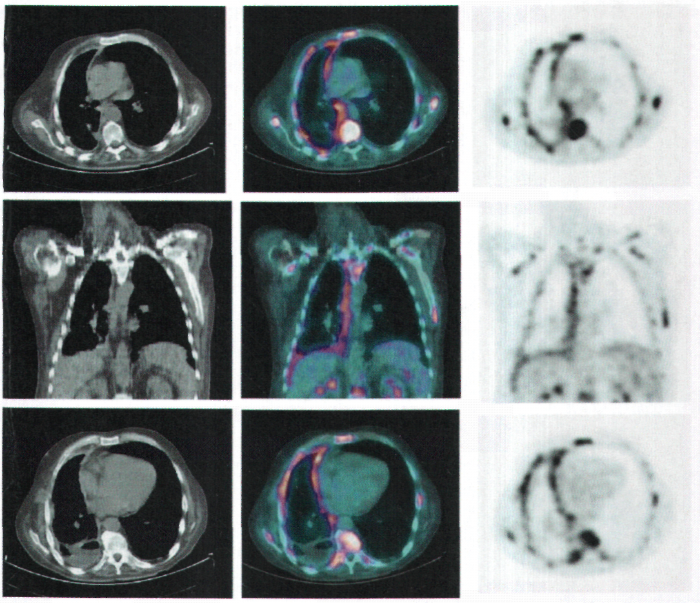
The value of semi-quantitative PET analysis in lymphocyte exudative pleurisy
The various studies that assess the value of PET in pleural disease are based on a visual analysis of the metabolic imaging. One might suppose that a semi-quantitative analysis of the images obtained by PET scan would be more objective than a visual interpretation, increasing the diagnostic accuracy. We attempted to support this assumption [33] on a cohort of 79 consecutive patients who presented with lymphocyte exudative pleural effusion for which no aetiology had been found after a CT-scan and thoracocentesis. As previously, all patients had PET before any invasive procedure was envisaged, but in this case the pleural metabolic images were processed using a semi-quantitative method based on SUV (Standard Uptake Value).
Six SUV parameters were calculated: SUVbw, SUVbsa, SUVlbm and correlated respectively to body weight, body surface area and lean body mass; these three SUV parameters were then corrected for glycaemia [34]. A formal histological diagnosis, obtained for each patient by thoracoscopy enabled us to discriminate between 28 cases of benign pleurisy (five cases were related to parapneumonia, three to tuberculosis, 12 were inflammatory, two asbestos-related, five consecutive to radiotherapy and one to uraemia) and 51 malignancies. In the latter group we found 18cases of metastatic pleural involvement related to extrathoracic cancer, 25 cases of metastatic pleurisy related to lung cancer and eight cases of mesothelioma. The ROC (Receiver Operating Curve) analysis showed areas under the curve between 0.803 and 0.863 in the distinction between benign and malignant pleurisy and between 0.763 and 0.818 when we compared the metastatic pleurisy of primary extrathoracic tumours with the metastatic pleurisy of thoracic tumours. From the methodological standpoint the SUVbw parameter was the most discriminatory for distinguishing the benign cases of pleurisy in the various sub-groups of tumoral pleurisy. The mean value of SUVbw was significantly higher in the malignant pleurisy group compared to the benign group (4.7 vs 1.9). The same was true of each sub-group of tumoral pleurisy in comparison to the benign group. Lastly, although no significant difference was found in the mean SUV values for the metastases of lung tumours and mesothelioma groups, both showed mean SUVbw values that were significantly higher than those of the pleural metastases of the extrathoracic cancer sub-group (5.5 et 5.6 vs 3.1). We researched a cut-off value and this showed us that a SUVbw of 2.2 was sufficient to differentiate malignant from benign pleurisy with a sensitivity, specificity and accuracy, of respectively 86%, 75% and 82%. The most accurate threshold value for dividing the metastatic pleurisies into groups on metabolic imaging (extrathoracic vs thoracic primary tumour) was 2.6 with a sensitivity of 94%, a specificity of 56% and an accuracy of 80%.
Semi-quantitative analysis of PET scan imaging of the pleura therefore confirms the previous results of visual analysis in this indication but because it identifies a cut-off value the interpretation becomes more objective. Calculating the SUV value also seems to afford guidance when seeking the primary tumour site if the patient has metastatic pleurisy. This suggests that metabolic imaging could therefore be a way of avoiding a substantial number of explorations if the patient's pleural SUVbw is less than 2.2.
Can semi-quantitative PET analysis be a factor of prognosis in mesothelioma?
Some studies [35,36] suggest that PET SUV values are an independent factor of prognosis in NSCLC [37]. A SUV above 4 may even indicate that the histology of a malignancy is more aggressive and thus be a factor of adverse outcome in NSCLC with only 3% surviving at 40 months against 88% with a SUV value below this threshold. FDG uptake may also be a factor of prognosis in mesothelioma, a primary pleural tumour: Benard et al. [38] suggested this hypothesis in 1999 when they reported on a cohort of 18 mesotheliomas, with a median survival of 5.3 months vs 15.6 months for patients with mean SUV values of respectively 6.6 vs 3.2. In this study, the Kaplan-Meier analysis confirmed a cumulative survival at 12 months of 17 vs 86% according to whether the pleural SUV value was above or below the median value of 4.03. A more recent study grouping 137 cases of mesothelioma [39], identified the SUV value as an independent predictive factor of survival, on a par with mixed cell-type and advanced stage. The risk of morality was 1.9 times higher with a very elevated pleural SUV value above 10. However, further studies must be carried out to definitively confirm the prognostic value of PET in mesothelioma.
The value of PET in staging non small cell lung cancer
One patient in three suffering from NSCLC presents at diagnosis with pleural metastases [40]. Fifteen percent of the patients with a diagnosis of NSCLC present with pleurisy [41]. Identifying a malignant pleural infiltration of NSCLC is of paramount importance because this information contributes to the prognosis and defines whether the case is amenable to surgical resection. The NSCLC classification T4 includes the presence of malignant pleurisy, which means that the tumour has spread and defines its local and regional extension, thereby excluding any possible surgical option. In the two cohorts we have reported from the literature [24,33], all the metastatic pleurisies related to lung cancer were correctly identified by PET. Any NSCLC with little or no FDG uptake (particularly if SUVbw is < 2.2) should be considered as potentially amenable to resection without necessarily having to resort to more invasive explorations. This is corroborated by the negative predictive value of various studies including pleurisy in a NSCLC setting [24,26,28-30]. Conversely, when there is increased uptake on the PET scan showing pleural hypermetabolism, histological proof should be obtained to make sure that a patient is not wrongly refused curative surgery. We feel that pleural PET analysis can contribute substantially to the staging, the decision to treat and the prognosis of NSCLC, just as a mediastinal or extrathoracic evaluation does. In all cases it should be part of the basic decision making processes in lung cancer.
Radiotherapy-related pleurisy
It is not always easy to identify a recurrence in lung disease after radiotherapy. PET would seem to have an indication in the follow-up of patients who have received radiotherapy for NSCLC [21]. When pleurisy occurs during radiotherapy once again the issue of whether the condition is caused by the radiotherapy or metastases is raised. In the articles published to date [24-32], post radiotherapy pleurisy has never shown signs of pleural hypermetabolism. We therefore feel that PET study of the pleura is a way of avoiding the more invasive explorations in when following up patients with NSCLC treated by radiotherapy (Fig. 2).

Figure 2. Transverse metabolic imaging slices of a patient with NSCLC of the right lower lobe treated by radiotherapy, showing no 18FDG uptake; the thoracoscopy proved that the pleurisy was consecutive to radiotherapy.
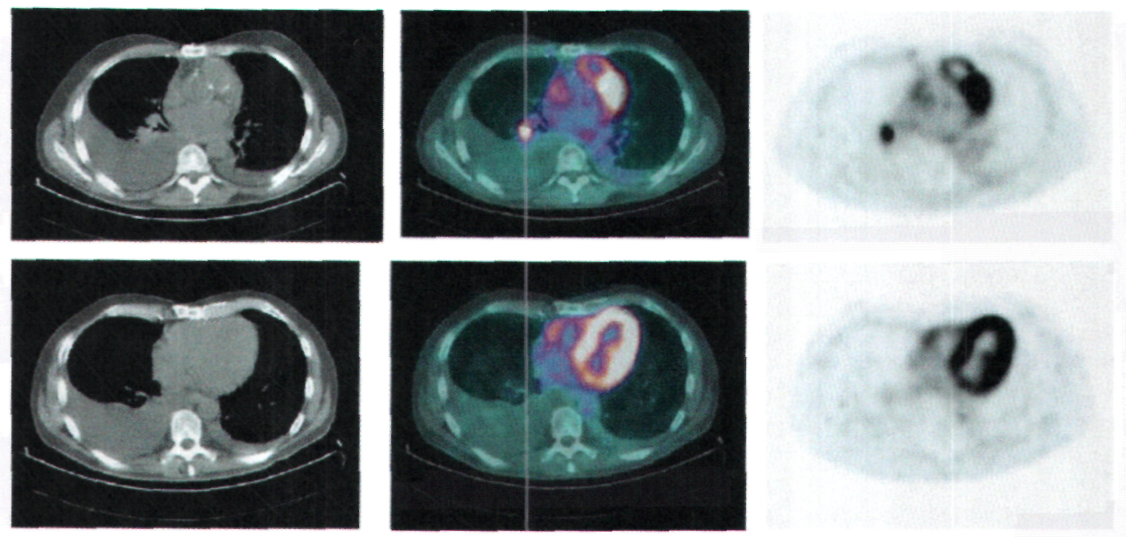

The value of PET in researching the primary tumour
When secondary metastatic pleurisy is diagnosed, the primary tumour site must be found to determine which chemotherapy regimen will be the most appropriate, as it must when any isolated lymph node, bone, skin, or brain metastasis of an unknown primary tumour is discovered. This is not always easy and the patient is often given a series of examinations, some of which may be both invasive and costly (gastroscopy, colonoscopy...). Although pulmonary and mammary tumours are statistically the most frequent causes of pleural metastases, various other malignancies such as the ovary, the stomach, the colon, the thyroid gland and the blood can also be the site of the primary neoplasm [9,10]. Some articles in the literature suggest that metabolic imaging may have some value in researching the primary tumour site in cases of «unknown primary » (CUP), a category to which pleural metastases can belong. This hypothesis is tenuous and is based on a small number of patients [42-46]; however it does imply that PET could be helpful it identifying the primary site in 24 to 73% of the cases according to the series. As we suggested in our semi-quantitative study of pleural hypermetabolism [32], these studies tend to indicate that PET might provide guidance on whether the primary tumour is thoracic or extrathoracic and, if so, this could reduce the burden and cost of further investigations, particularly when choosing the initial exploration.
The value of PET in monitoring pleural thickening and recurrent pleurisy
Thoracoscopy is highly sensitive and specific for exploring pleural disease. However, it is difficult to offer it repeatedly in cases of recurrent inflammatory or occupational pleurisy, even if the disease is potentially carcinogenic. It is in particular difficult to monitor asbestos-related pleurisy and in patients exposed to asbestos fibres the difficult issue at stake is to exclude the emergence of a malignancy without systematically repeating invasive explorations. If we refer to the studies quoted above it is interesting to see that all the cases of benign, asbestos-related pleurisy were correctly identified on PET. PET also has a high negative predictive value in the differential diagnosis of mesothelioma vs benign pleural diseases. On a cohort of 30 patients exposed to asbestos who presented with pleural and/or pulmonary anomalies Melloni et al. [47] reported that metabolic imaging had a sensitivity of 89% and a specificity of 76% in showing the onset of malignant pleural (n = 7) or pulmonary (n = 2) disease. For this reason we feel that metabolic exploration of the pleura has a role to play in monitoring recurrent pleurisy without systematically having to resort to invasive exploration, especially if there is a potential risk of a malignancy developing. It is also possible that the surveillance of pleural thickening will also be justified in the future.
Talc pleurodesis
Pleural sclerosis with talc is an acknowledged symptomatic treatment in malignant pleurisy. It is method of treating recurrent pleurisy that alleviates the patient's dyspnoea, and eliminates the need for repeated pleural puncture [48]. Two studies [49,50] reported that talc pleurodesis induces a granulomatous inflammatory reaction that can be a source of false positives on the metabolic imaging. It can in fact simulate a malignant pleural disorder, sometimes with a mean SUV of 5.4 that can last as long as 22 months. Our personal experience in 15 patients (eight cases of malignant pleurisy, five benign cases, two cases of recurrent pneumothorax) agrees with the findings in the literature. We noted increased 18FDG uptake in all cases when PET was performed between 7 days and 42 months after talc pleurodesis. PET therefore does not seem to be suitable for assessing or monitoring the treatment of patients with malignancies whose symptoms are treated by talc pleurodesis.
Conclusion
PET can discriminate between benign and malignant pleural disorders. Far from replacing thoracoscopy, it is part of the process of exploring a pleural pathology. It has an excellent negative predictive value, which means that an escalation of invasive examinations can be avoided if there is no increase in 18FDG uptake in the pleura. A semi-quantitative analysis of pleural metabolism contributes a more objective approach and defines threshold values that discriminate benign pleural pathologies from malignancies on one hand and differentiate pleural metastases according to whether the primary tumour is intra or extra-thoracic. A semi-quantitative analysis of pleural metabolic activity is also a factor of prognosis in mesothelioma. The input of PET in the exploration and follow-up of recurrent pleurisy has a true clinical value, especially when it is asbestos-related. Lastly, pleural metabolism is of first-rate interest in the initial staging and in following up the treatment of pulmonary cancer.
Conflict of interest
No conflict of interest.
References
[1] Leung A, Muller N, Miller R. CT in differential diagnosis of diffuse pleural disease. Am J Roentgenol 1990 Mar; 154:487-92.
[2] Dedrick CG, McLoud TC, Shepard JA, Shipley RT. Computed tomography of localized pleural mesothelioma. Am J Roentgenol 1985;144:275-80.
[3] Light RW, Macgregor Ml, Luchsinger PC, Ball WC. Pleural effusions: the diagnositic of transudates and exsudates. Ann Intern Med 1972;77:507-13.
[4] Light RW, Erozan YS, Ball WC. Cells in pleural fluid. Their value in differential diagnosis. Arch Intern Med 1973;132:854-60.
[5] Schönfeld N, Loddenkemper R. Pleural biopsy and thoracoscopy. Eur Respi Mon 1998;9:135-52.
[6] Prakash U, Reiman H. Comparison of needle biopsy with cytologic analysis for the evaluation of pleural effusion: analysis of 414 cases. Mayo Clin Proc 1985;60:158-64.

[7] Von Hoff D, Di Volsi V. Diagnostic reliability of needle biopsy of the parietal pleura: a review of 272 biopsies. Am J Clin Pathol 1979;72:48-51.
[8] Boutin C, Viallat JR. Rey F. Manuel pratique des techniques pleurales. France: Springer-Verlag; 1991, 59-63.
[9] Sahn S, Malignant pleural effusions. Eur Respir Monograph 2002;22:177-88.
[10] Antunes G, Neville E, Duffy J, on behalf of the BTS Pleural Disease Group, a subgroup of the BTS Standards of Care Committee. BTS guidelines for the management of malignant pleural effusions. Thorax 2003;58(Suppl. II):ii29-38.
[11] Sahn S. Malignant pleural effusions. In: Fischman AP, editor. Pulmonary diseases and disorders. 2nd ed. New York: Mc Graw-Hill; 1988. p. 2159-70.
[12] Bury T, Daenen F, Duysinx B, Bartsch P, Corhay JL. Applications en oncologie thoracique de la TEP-18FDG. Rev Mai Respir 2001;18:623-30.
[13] Vansteenkiste JF. Imaging in lung cancer: positron emission tomography scan. Eur Respir J Suppl 2002;35:49s-60s.
[14] Bury T. Duysinx B, Corhay JL, Bartsch P, Rigo P. Comment j'explore ... un cancer broncho-pulmonaire par imagerie metabolique (TEP-18-FDG). Rev Med Liege 2000;55:178-83.
[15] La Tomographie à émission de positons (TEP). In: Standards Options et Recommandations: le cancer bronchopulmonaire non à petites cellules. John Libbey Eurotext; 2002, p. 86-8.
[16] Bury T, Dowlati A, Paulus P, Corhay JL, Benoit T, Kayembe JM, et al. Evaluation of the solitary pulmonary nodule by positron emission tomography imaging. Eur Respir J 1996;9:410-4.
[17] Bury T, Paulus P, Dowlati A, Corhay JL, Weber T, Ghaye B, et al. Staging of the mediastinum: value of positron emission tomography imaging in non-small cell lung cancer. Eur Respir J 1996;9:2560-4.
[18] Vaylet F, Bonardel G, Salles Y, Bonnichon A, Gontier E, Margery J, et al. La tomographie par emission de positons au 18fluoro-deoxy-gtucose (18FDG-TEP) et le bilan initial du cancer bronchique. Rev Mal Respir 2005;22, 8S43-48.
[19] Hustinx R, Paulus P, Jacquet N, Jerusalem G, Bury T, Rigo P. Clinical evaluation of whole-body 18F-fluorodeoxyglucose positron emission tomography in the detection of liver metastases. Ann Oncol 1998;9:397-401.
[20] Bury T, Barreto A, Daenen F, Barthelemy N, Ghaye B, Rigo P. Fluorine-18 deoxyglucose positron emission tomography for the detection of bone metastases in patients with non-small cell lung cancer. Eur J Nucl Med 1998;25:1244-7.
[21] Bury T, Corhay JL, Duysinx B, Daenen F, Ghaye B, Barthelemy N, et al. Value of FDG-PET in detecting residual or recurrent nonsmatl cell lung cancer. Eur Respir J 1999;14:1376-80.
[22] Meignan M, Paone G. La tomographie par émission de positons (TEP) au 18-fluoro-déoxy-glucose (18FDG) dans l'évaluation de la pathologie pleurate maligne. Rev Pneumol Clin 2006;62:128-34.
[23] Bénard F, Sterman D, Smith PJ, Kaiser LR, Albelda SM, Alavi A. Metabolic imaging of malignant pleural mesothelioma with fluorodeoxyglucose positron emission tomography. Chest 1998;114:713-22.
[24] Duysinx B, Nguyen D, Louis R, Cataldo D, Belhocine T, Bartsch P, et al. Evaluation of pleural disease with 18-Fluorodeoxyglucose positron emission tomography imaging. Chest 2004;125:489-93.
[25] Kramer H, Pieterman RM, Slebos DJ, Timens W, Vaalburg W, Koëter GH, et al. PET for evaluation of pleural thickening observed on CT. J Nucl Med 2004;45:995-8.
[26] Schaffler GJ, Wolf G, Schoellnast H, Groell R, Maier A, Smolle-Jüttner FM, et al. Non-small cell lung cancer: evaluation of pleural abnomalies on CT scans with 18F FDG PET. Radiology 2004;231:858-65.
[27] Carretta A, Landoni C, Melloni G, Ceresoli GL, Compierchio A, Fazio F, et al. 18-FDG-positron emission tomography in the evaluation of malignant pleural dieases - a pilot study. Eur J Cardio-thorac Surg 2000;17:377-83.
[28] Erasmus JJ, McAdams HP, Rossi SE, Goodman PC, Coleman RE, Patz EF. FDG PET of pleural effusions in patients with non-smalt cell lung cancer. AJR Am J Roent 2000;175:245-9.
[29] Gupta NC, Rogers JS, Graeber GM, Gregory JL, Waheed U, Mullet D, et al. Clinical role of F-18 Fluorodeoxyglucose positron emission tomography imaging in patients with lung cancer and suspected malignant pleural effusion. Chest 2002;122:1918-24.
[30] Bury T, Paulus P, Dowlati A, Corhay JL, Rigo P. Radermecker MF. Evaluation of pleural disease with FDG-PET imaging: preliminary report. Thorax 1997;52:187-9.
[31] Toaff JS, Metser U, Gottfried M, Gur 0, Deeb ME, Lievshitz G, et at. Differentiation between malignant and benign pleural effusion in patients with extra-pleural primary malignancies. Assessment with positron emission tomography-computed tomography. Investigative Radiology 2005;40:204-9.
[32] Balogova S. Grahek D, Kerrou K, Montravers F, Younsi N, Aide N, et al. L'imagerie nucléaire au 18FDG dans les lésions pleurales en apparence isolées. Rev Pneumol Clin 2003;59:275-88,
[33] Duysinx B, Larock MP, Nguyen D, Corhay JL, Bury T, Hustinx R, et at. 18F-FDG PET imaging in assessing exudative pleural effusions. Nucl Med Commun 2006:27:971 -6.
[34] Menda Y, Bushnett DL, Madsen MT, McLaughtin K, Kahn D, Kernstine KH. Evaluation of various corrections to the standardized uptake value for diagnosis of pulmonary malignancy. Nucl Med Com 2001;22:1077-981.
[35] Vansteenkiste JF, Stroobants SG, Dupont PJ, De Leyn PR, Verbeken EK, Deneffe GJ, et al. Prognostic importance of the standardized uptake value on (18)F-ftuoro-2-deoxy-gtucose-positron emission tomography scan in non-small-cell lung cancer: An analysis of 125 cases. Leuven lung cancer group. J Clin Oncol 1999;17:3201-6.
[36] Dhital K, Saunders CA, Seed PT, O'Doherty MJ, Dussek J. [(18)F]Fluorodeoxyglucose positron emission tomography and its prognostic value in lung cancer. Eur J Cardiothorac Surg 2000;18:425-8.
[37] Higashi K, Ueda Y, Ayabe K, Sakurai A, Seki H, Nambu Y, et al. FDG PET in the evaluation of the aggressiveness of pulmonary adenocarcinoma: correlation with histopathological features. Nucl Med Commun 2000;21:707-14.
[38] Bénard F, Sterman D, Smith RJ, Kaiser LR, Albelda SM, Alavi A. Pronostic value of 18F-FDG PET imaging in malignant pleural mesothelioma. J Nucl Med 2000;41:1443-4.
[39] Flores RM, Akhurst T, Gonen M, Zakowski M, Dycoco J, Larson SM, et al. Positron émission tomography predicts survival in malignant pleural mesothelioma. J Thorac Cardiovasc Surg 2006;132:736-8.
[40] Trail ZC, Davis RJ, Gleeson FV. Thoracic computed tomography in patients with suspected malignant pleural effusions. Clin Radiol 2001;56:193-6.
[41] Dwamena BA, Sonnad SS, Angobatdo JO, Wahl RL. Metastases from non-small cell lung cancer: mediastinal staging in the 1990s - a meta-analytical comparaison of PET and CT. Radiology 1999;213:530-6.
[42] Kole AC, Nieweg OE, Pruim J, Hoekstra HJ, Koops HS, Roodenburg JL, et al. Detection of unknown occult primary tumors using positron emission tomography. Cancer 1998;82: 1160-6.
[43] Bohuslavizki KH, Ktutmann S, Kröger S, Sonnemann U, Buchert R, Werner JA, et al. FDG PET detection of unknown primary tumors. J Nucl Med 2000;41:816-22.
[44] Alberini JL, Belhocine T, Hustinx R, Daenen F, Rigo P. Wholebody positron emission tomography using fluorodeoxyglucose in patients with metastases of unknown primary tumors (CUP syndrome). Nucl Med Commun 2003;24:1081-6.
[45] Mantaka P, Baum RP, Hertel A, Adams S, Niessen A, Sengupta S, et al. PET with 2-[F-18]-fluoro-2-deoxy-D-glucose (FDG) in patients with cancer of unknown primary (CUP): influence on patients' diagnostic and therapeutic management. Cancer Biother Radiopharm 2003;18:47-58.
[46] Rades D, Kühnel G, Wildfang I, Börner AR, Schmoll HJ, Knapp W. Localised disease in cancer of unknown primary (CUP); the value of positron emission tomography (PET) for individueal therapeutic management. Ann Oncol 2001;12:1605-9.
[47] Melloni B, Monteil J, Vincent F, Bertin F, Gaillard S, Ductoux T, et at. Assessment of 18F-fluorodeoxyglucose dual-head gamma camera in asbestos lung diseases. Eur Respir J 2004;24: 814-21.
[48] Dresler CM, Olak J, Herndon JE, Richards WG, Scalzetti E, Fleishman SB, et al. Phase III intergroup study of talc poudrage vs talc slurry sclerosis for malignant pleural effusion. Chest 2005;127:909-15.
[49] Weiss N, Solomon S. Talc pleurodesis mimics pleural metastases. Differentiation with positron emission tomography/computed tomography. Clin Nucl Med 2003;28:801-14.
[50] Kwek B, Aquino S, Fischman A. Fluorodeoxyglucose positron emission tomography and CT after talc pleurodesis. Chest 2004;125:2356-60.

