**Al-Naamani L, Dobretsov S, Dutta J, Burgess JG.**[**Chitosan-zinc oxide nanocomposite coatings for the prevention of marine biofouling**](https://myimpact.ncl.ac.uk/ViewPublication.aspx?id=232602)**.   
*Chemosphere* 2017, 168, 408-417.**

**Copyright:**

© 2017. This manuscript version is made available under the [CC-BY-NC-ND 4.0 license](http://creativecommons.org/licenses/by-nc-nd/4.0/)

**DOI link to article:**

<http://dx.doi.org/10.1016/j.chemosphere.2016.10.033>

**Date deposited:**

28/02/2017

**Embargo release date:** 28/10/2017

**Chitosan-zinc oxide nanocomposite coatings for the prevention of marine biofouling**

Laila Al-Naamani a,b, Sergey Dobretsov a, c*, Joydeep Dutta d**, J. Grant Burgess b

a Department of Marine Science and Fisheries,

Sultan Qaboos University, 123 Al-Khodh, Oman

b School of Marine Science and Technology,

Newcastle University, Newcastle upon Tyne, NE1 7RU, UK

c Center of Excellence in Marine Biotechnology,

Sultan Qaboos University, 123 Al-Khodh, Oman

d Functional Materials Division,

Materials and Nano Physics Department,

ICT School, KTH Royal Institute of Technology,

SE-164 40, Kista, Stockholm, Sweden

* *Corresponding author E-mail:*  [*sergey@squ.edu.om*](mailto:sergey@squ.edu.om)

*\*\* Corresponding author E-mail:* [*joydeep@kth.se*](mailto:joydeep@kth.se)

ABSTRACT

Marine biofouling is a worldwide problem affecting maritime industries. Global concerns about the high toxicity of antifouling paints have highlighted the need to develop less toxic antifouling coatings. Chitosan is a natural polymer with antimicrobial, antifungal and antialgal properties that is obtained from partial deacetylation of crustacean waste. In the present study, nanocomposite chitosan-zinc oxide (chitosan-ZnO) nanoparticle hybrid coatings were developed and their antifouling activity was tested. Chitosan-ZnO nanoparticle coatings showed anti-diatom activity against *Navicula* sp. and antibacterial activity against the marine bacterium *Pseudoalteromonas nigrifaciens.* Additional antifouling properties of the coatings were investigated in a mesocosm study using tanks containing natural sea water under controlled laboratory conditions. Each week for four weeks, biofilm was removed and analyzed by flow cytometry to estimate total bacterial densities on the coated substrates. Chitosan-ZnO hybrid coatings led to better inhibition of bacterial growth in comparison to chitosan coatings alone, as determined by flow cytometry. This study demonstrates the antifouling potential of chitosan-ZnO nanocomposite hybrid coatings, which can be used for the prevention of biofouling.

**Keywords:** Antifouling, Chitosan, ZnO nanoparticles, Nanocomposite Coating, Biofilm.

**Graphical abstract**

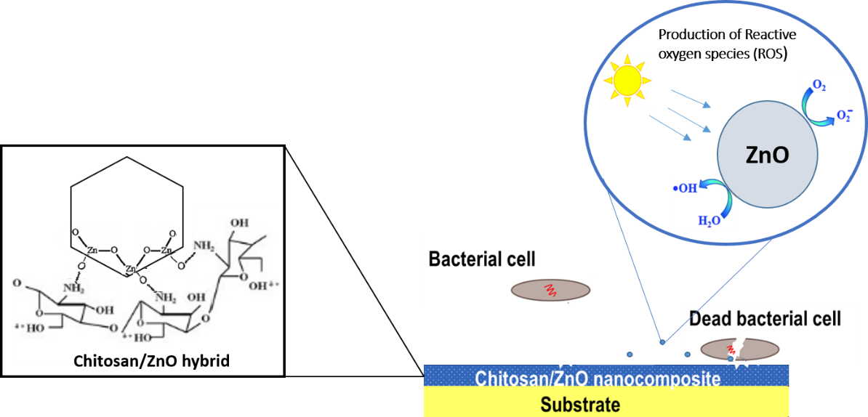

**Highlights**

* Nanocomposite chitosan-ZnO nanoparticle hybrid coatings were developed.
* Incorporation of ZnO in the chitosan matrix improved physical characteristic of the coating.
* Chitosan-ZnO nanocomposite coatings showed high antidiatom and anti-bacterial activity.
* Chitosan-ZnO nanocomposite coatings represent a promising strategy for the prevention of biofouling.

**1. Introduction**

Marine biofouling is the accumulation or adsorption of micro- and macro-organisms on wet surfaces and is a worldwide problem affecting aquatic industries. Biofouling can reduce speed and manoeuvrability of ships, accelerate corrosion and increase fuel consumption, as well as increase the risk of mechanical failure of static structures, such as buoys, piers, and jetties (Sudha et al. 2015). Biofouling occurs on practically all surfaces starting with the adhesion of organic molecules such as proteins and polysaccharides followed by the subsequent attachment of bacteria, diatoms and microalgae to form a biofilm which is then followed by the adhesion of macro-organisms, such as bryozoans, barnacles, bivalves and macro-algae (Dobretsov 2009a; Magin et al. 2010). However, these stages can also overlap or occur in parallel. Once biofouling communities are established, it is very difﬁcult to remove them (Yebra et al. 2004). Thus, antifouling compounds and coatings are applied in order to prevent cell adhesion and/ or kill approaching cells (Yang et al. 2014).

Traditionally, self-polishing antifouling coatings were used to prevent bio-fouling on ship hulls (Yebra et al. 2004). These coatings work by the gradual erosion and release of toxic biocides, like copper (Buskens et al. 2013). Most of the compounds are found to have harmful effects on non-target organisms leading to some of them like tributyltin being banned (Champ 2000; Vold 2003; Yebra et al. 2004).Therefore, the development of non-toxic and broadly effective antifouling materials is urgently required.

Many efforts have been made to develop novel, less toxic coatings for the prevention of biofouling (Mobarak et al. 2013; Malini et al. 2015). Polymers are the most popular materials for the development of antifouling coatings due to their ease of application (Malini et al. 2015; Murata et al. 2007). The antifouling polymer coatings that have been developed in recent years imply three main antifouling strategies: preventing biofouling organisms from attaching to surfaces (fouling-resistant coatings), reducing the adhesion of biofoulants (fouling release coatings) and killing of biofoulants (fouling-degrading coatings) (Yang et al. 2014).However,there are no effective antifouling coatings available right currently which are also non toxic.

Chitosan is a naturally occurring linear cationic polysaccharide composed of D-glucosamine and N-acetyl-D-glucosamine which is obtained by the partial deacetylation of chitin (Xiao 2012). Previous studies have reported chitosan as an excellent film forming biopolymer with antimicrobial and antifungal properties (Lagarón et al. 2011). Chitosan possesses antibacterial and antifungal properties because of its cationic nature, which makes it possible to interact with the negative charges of the microbial cell membrane (Kim and Rajapakse 2005; Alisashi and Aider 2012). It has been used in different applications as an antimicrobial coating due to its biocompatibility, biodegradability, antibacterial properties, low toxicity, ecological safety, susceptibility to chemical modiﬁcations and cost effectiveness (Kaushik et al. 2008; Pillai et al. 2009; Haldorai and Shim 2013). Chitosan is also used in pharmaceuticals, agriculture, food science and biomedical products (Gandhi and Meenakshi 2012; Kashyap et al. 2015; Youssef e al. 2015). The short-term antifouling activity of chitosan-based paints has also been reported (Pelletier et al. 2009). However, despite the positive properties of chitosan-based films and coatings, they also have some limitations such as poor mechanical strength (Xiao 2012). One successful approach to enhance mechanical and antimicrobial properties of chitosan coatings is by the incorporation of inorganic nanomaterials in the polymer matrix to produce a composite material (Saravanan et al. 2011; Rahman et al. 2015; Yadollahi et al. 2015). Metal oxide nanoparticles have attracted particular interest for their broad-spectrum antimicrobial (i.e., antibacterial, antiviral, and antifungal) activities (Palza 2015) and minimal adverse effects on mammalian cells (Fu et al. 2005).

Compared to other metal oxide nanoparticles, ZnO nanoparticles have attracted attention due to their lower cost, lack of color and their UV blocking properties, amongst others (Kim and Osterloh, 2005; Dastjerdi and Montazer 2010; Perelshtein et al. 2013). ZnO NPs are used in food processing and agriculture because of their biocompatibility, low toxicity and antimicrobial activity (Reddy et al. 2007). ZnO is also listed by FDA (Food and Drug Administration, USA) as a safe material (Emamifar et al. 2010). Recent studies have revealed that chitosan-ZnO complexes have promising potential for application as antimicrobial, anti-bioﬁlm (Dhillon et al. 2014) and antifouling agents with enhanced physical properties (Malini et al. 2015; Abiraman et al. 2016).

In this study the antifouling activity of chitosan and ZnO-chitosan nanocomposite hybrid coatings was investigated. The specific aims were to: develop and characterize chitosan and ZnO-chitosan nanocomposite coatings; test anti-diatom activity against the diatom *Navicula incerta* and to test antibacterial activity against the marine bacterium *Pseudoalteromonas nigrifaciens*; investigate antifouling activity of the coatings in a mesocosm experiment over 4 weeks.

**2. Materials and Methods**

***2.1 Materials***

Medium molecular weight chitosan with a viscosity of 110 cps and a 95.6% deacetylation degree was purchased from Tru-Nutra Nutraceuticals LLC, India. Commercial ZnO nanoparticles were purchased from SIGMA Aldrich, USA. Paraformaldehyde and phosphate buffered saline (PBS) were obtained from (SIGMA Aldrich, UK).

***2.2 Methods***

**2.2.1 Characterization of Commercial ZnO nanoparticles**

Particle size distribution of commercial ZnO powder (35-45 nm, Sigma, USA) was determined using a CILAS NanoDS (France) dynamic light scattering (DLS) particle size analyzer. Size of the particles was also determined by High Resolution Transmission Electron Microscopy (HRTEM, JEOL JEM-2100F, Japan) working at 200 kV.

**2.2.2 Preparation of hybrid nano-coatings**

A nanocomposite solution was prepared by the addition of 0.2 g of commercial ZnO nanoparticles into 1 % acetic acid (Sigma Aldrich, UK). The solution was mixed for about 10 min and then 1.5 g of chitosan powder was added and mixed vigorously and then sonicated for 15 min. 0.1 M NaOH (Sigma Aldrich, UK) was added slowly to this solution with vigorous stirring until the pH reached 6.0 and the solution was kept overnight at 60 °C. Glass slides (25 mm × 75 mm) were cleaned with ethanol and coated on one side with the nanocomposite solution and allowed to dry overnight at room temperature (25 °C). After the coating was completely dried it was then rinsed twice with hot 0.1 M NaOH (85 °C) and dried again at room temperature (25 °C). For comparison, chitosan coatings on glass slides were prepared using 1.5 % chitosan solution in 1 % acetic acid as describe above.

**2.2.3 Coating characterization**

***2.2.3.1 Morphological and water affinity analysis***

Surface morphology of all coated substrates were characterized by field emission scanning electron microscope (FESEM) working at 20 kV. Energy-Dispersive X-ray Spectrometry (EDX) was used to determine the elemental composition of the coatings.

To determine the hydrophilic/ hydrophobic properties of the coatings, the surface water contact angle was measured using a goniometer (Ramé-Hart Instrument Co., USA). A drop of Milli-Q water was placed on the film surface and the evolution of the droplet shape was recorded with a video camera. Image analysis software (DROPimage Advanced v2.2, USA) was used to determine the contact angle and surface energy. The measurements were conducted over five different locations of the coating surface and the mean WCA was reported. For comparison, the same procedure was repeated using seawater as a working solution. A second measurement was made after a relaxation time of 5 min for both liquids. For each contact angle, surface energy was calculated according to Owens and Wendt (1969).

The swelling and solubility of the coatings in water was determined following Casariego et al. (2009) and Zhong et al. (2011) with minor modifications. Coated glass slides (25 mm × 75 mm) were dried in an oven at 70 °C for 24 h (to a constant weight) to determine the initial dry weight (M1). Then the dry slides were placed in 50 mL de-ionized water at 30 °C under constant agitation. After 48 h of immersion, the wet weight (M2) of the samples was measured immediately after excess water was removed by adsorption using filter paper (Whatman No. 1). The coated slides were dried again in an oven at 70 °C for 24 h (to a constant weight) to determine the final dry weight (M3). Three replicates of each coating were taken and the weights were rounded to the nearest 0.0001 g. The swelling and solubility percentages of the coatings were calculated using the following equations:

$$Swelling ratio (\%)=\frac{M_{2}-M_{1}}{M_{1}}x 100$$

$$Film solubility (\%)=\frac{M_{1}-M_{3}}{M_{1}}x 100$$

***2.2.3.2 Diatom and bacterial assays***

Anti-diatom activities of the coatings were evaluated using the diatom *Navicula incerta* (Grunow)*.* A culture of this diatom was obtained from the School of Marine Science and Technology, Newcastle University, UK. The diatom cells were cultured in F/2 medium at 26 ° C for 3 days until log phase. In this experiment, coated (treated) and uncoated microscope glass (control) slides were placed in quadriPERM dishes (Starstedt, Germany) with 4 compartments. Ten ml of *N. incerta* suspension in F2 medium (OD660 nm ~0.015) was transferred into each compartment. The dishes were then incubated under constant luminescent light (wave length = 400-750 nm, intensity =15 W m-2) at room temperature for 7 days. After incubation, the slides were removed and attached cells were investigated under a microscope. All experiments were carried out in triplicate and the mean densities of diatoms were calculated.

To characterize the ability of the coatings to inhibit the growth of marine bacteria upon contact, bacterial density after direct exposure to the coated substrates was assessed using *Pseudoalteromonas nigrifaciens*, a species commonly found in biofilms. The antibacterial effect of the coated and uncoated glass slides against *P. nigrifaciens* was determined by a suspension culture medium test according to Leceta et al. (2013), with some modifications. This test is an end point assay that provides information about the inhibition of microbial growth at a specific time point. The bacterial strain was previously cultivated in marine broth (SIGMA Aldrich, UK) for 24 h at 30 °C. After incubation, the bacterial culture was diluted with autoclaved marine broth to an initial density of 107 cell/ ml. One slide (25 mm × 75 mm) coated with chitosan-ZnO nanocomposite and one uncoated slide were placed in sterile flasks and 50 ml of the bacterial culture was added. The experiment was carried out in triplicate at 30 °Cwith agitation (20 rpm) for 1, 2 and 5 days under light (wave length = 400-750 nm, intensity = 15 W m-2) and dark conditions. Agitation ensures a homogeneous and continuous contact between bacteria and the coatings.At each sampling day, the optical density (OD) of the culture at 600 nm was measured to assess the antibacterial activity of the coatings. Changes in bacterial growth were determined by the comparison of OD of the cultures between the treatments and the control.

**2.2.4 Mesocosm experiment**

Adhesion of biofouling microorganisms to coated microscope slide surfaces were tested in small aquaria in our indoor experimental facilities. Three small aquaria were prepared and filled with 20 L of natural sea water (salinity: 30 ppt and pH 7.6). Coated slides were immersed in the aquaria. Each aquarium contained three hybrid Chitosan/ZnO coated slides, three chitosan coated slides, and three controls (uncoated slides). All slides were placed horizontally at a distance of 10 cm from the water surface and 8 cm from the bottom. Two experiments were done in parallel under luminescent light (wave length = 400-700 nm, intensity = 15 W m-2) and dark conditions at room temperature (25 °C) and samples were collected after 1, 2 and 4 weeks.

Before the sample collection, 2 ml of water from a distance of about 1 cm from the top of the aquarium were carefully collected with a pipette and stored at -80 °C for further analysis. The concentration of Zn ions in the water samples was determined by [Inductively Coupled Plasma Mass Spectrometry](https://www.google.co.uk/url?sa=t&rct=j&q=&esrc=s&source=web&cd=4&cad=rja&uact=8&ved=0ahUKEwj0so6C-qrLAhWrK5oKHZZ9DHEQFggqMAM&url=https%3A%2F%2Fen.wikipedia.org%2Fwiki%2FInductively_coupled_plasma_mass_spectrometry&usg=AFQjCNEdpapNkEgOJ91Yp2lID9u-WJXRvg&bvm=bv.116274245,d.bGs) (ICP-MS).

At each sampling time, one slide of each treatment was taken from each container (total 9 slides, 3 replicates for each coating). Biofilm attached to the slides was scraped off using a sterile scalpel (for details see Muthukrishnan et al. 2014). Biofilm samples were fixed with 3 % paraformaldehyde in PBS (1:1) and then stored at -80 °C for further analysis (see below).

For the observation of live bacterial cells in the biofilms, 10µl of the resulting biofilm suspension was placed on a microscope glass slide and stained with Syto 9 (Life Technologies, Thermo Fisher, Waltham, MA, USA). The samples were kept for 15 min in the dark and then the live bacteria were observed using a fluorescent microscope (Leica Microsystems CMS GmbH, Germany).

The development of bacterial biofilm growth on the chitosan/ ZnO nanocomposite coated glass slides was monitored over the incubation period compared to chitosan coated and uncoated slides. Biofilm samples were stained for 15 min in dark with SYBR green stain (excitation/emission wavelengths: 497 nm/ 520 nm; dilution 1:10,000) and analysed by flow cytometry (FACSCanto II cytometer).

**2.2.5 Statistical Analysis**

Data was subjected to the analysis of variance (ANOVA). Prior the analysis, the data were checked for normality. Sources of variation were different treatments and incubation periods. Difference between treatments were determined by the highest significant difference (HSD) test, at a significant level p < 0.05.

**3. Results and discussion**

**3.1 Commercial ZnO Nanoparticles**

Mean size of the nanoparticles were found to be in the range of 50-60 nm (Figure 1a) which agrees with the sizes as observed under the transmission electron microscopy (Figure 1b).

**Figure 1.**

**3.2 Characterization of coated samples**

*3.2.1 Morphological and water affinity observation*

The surface morphology of the coated and uncoated glass slides is shown in Figure 2. The scanning electron micrographs (SEM) demonstrate the smooth surface of chitosan coating on the glass substrate (Figure 2b). In Figure 2 (c) we can observe that the surface morphology changes with incorporation of ZnO nanoparticles in the chitosan matrix, as clusters of nanoparticles of about 100-150 nm are found embedded in the coated matrices. Figure 3 illustrates a typical EDX spectrum of chitosan-ZnO nanocomposite coating. The composition analysis by EDX showed peaks of zinc in the spectra, confirming the presence of ZnO nanoparticles in the coating. No traces of lead were observed (Figure 3). Similar results have been shown earlier (Al Fori et al. 2014).

Water contact angle (WCA) provide information on the wettability of coatings and it is a good indicator of the hydrophilic or hydrophobic nature of materials (Rivero et al. 2013). The WCA of the chitosan coating was ~ 50.5° but dropped by 12 % after 5 min, showing a high degree of wettability of the coated surface (Table 1). Chitosan/ZnO nanocomposite hybrid coatings showed a significantly lower hydrophilicity with a WCA of ~ 60°, with a slight decrease observed in this value (~5 %) after 5 min of exposure to water. In comparison, using seawater as a working solution, no significant differences in the WCA were observed (Table 1). The estimated surface energy of the nanocomposite hybrid coating was lower than that of chitosan, and in both coatings it increased slightly after 5 min. It was previously demonstrated that membrane fouling occurs more seriously on hydrophobic membranes than hydrophilic ones because of hydrophobic interactions between solutes, microbial cells, and membrane surfaces (Kim et al. 2004). On the other hand, energy of a surface is one of the most relevant physicochemical parameters inﬂuencing the settlement and the adhesion strength of fouling organisms (Ista et al. 2004; Liu and Zhao2005; Lejars et al. 2012).

Solubility and swelling (Table 2) are two important characteristics of biodegradable films because they can affect the water resistance of the films. Incorporation of ZnO significantly (p <0.05) decreased the swelling ratio of the coating from 1.53 % for chitosan coatings to 0.49 % for the nanocomposite hybrid coatings. When ZnO was incorporated in the chitosan matrix the coating solubility was found to decrease to a large extent (Table 2). Solubility of coatings is usually related to their hydrophilic properties, while swelling behaviour is affected by water diffusion, ionization of amino or carboxyl groups, dissociation of hydrogen and ionic bonds, and polymer relaxation (Mathew et al. 2006). The decrease in swelling ratio in our study indicates that incorporation of ZnO provided a stabilization effect to the coating matrix, probably by the formation of a three dimensional network of nanoparticles (Das et al. 2014). This reduces the mobility of the chitosan chains and minimizes swelling (Reicha et al. 2012).

**Figure 2.**

**Figure 3.**

**Table 1.**

**Table 2.**

*3.2.3 Antibacterial and antidiatom assays*

The present study was conducted on the diatom *Navicula*, which is dominant in marine biofilms (Molino and Wetherbee 2008; Dobretsov 2009b). These species are also of great interest because of their resistance to biocides in commercial antifouling paints and difficulty of removing them from surfaces once attached (Molino and Wetherbee 2008; Lejars et al. 2012). The slight decrease in diatom density on the chitosan coating (Fig. 4) could be attributed to changes in the surface wettability of the polymer surface. It is known that adhesion of diatoms is influenced by the gel strength (rigidity and breakpoint), coating surface energy or wettability, and the concentration of functional groups at the surface (Rasmussen and Østgaard 2001). Rasmussen and Østgaard (2001) found lower adhesion of diatom *Amphora coffeaeformis* on a glass substrate in comparison with one coated with chitosan. However, a more recent study by Bennett et al. (2010) showed an increase in removal of *Navicula perminuta* when the surface wettability increased.

The chitosan coating led to a 16 % reduction in the density of diatoms compared to uncoated control samples (Fig. 4). In comparison, a complete inhibition of diatom growth and settlement was observed on the chitosan-ZnO nanocomposite hybrid coatings (Fig.4). The diatom biofilm on the uncoated control sample consisted of large clumps of cells, while fewer single cells could be observed on the chitosan coating (Fig. 5 a & b). The control of algal growth by chitosan was reported previously (Ravi Kumar 2000).However, when chitosan was directly tested in the marine environment as an additive to various antifouling paints, its anti-algal activity was not observed (Pelletier et al. 2009). In the presence of ZnO nanoparticles diatoms cells were destroyed (Fig. 5(c)). The nanocomposite hybrid coating gave the best inhibition of diatom attachment. To our knowledge, this work is the first to show anti-diatom activity of chitosan-ZnO nanocomposite coatings.

Antibacterial experiments using *P. nigrifaciens* showed that under light irradiation the control (uncoated slide) had a significantly higher (p<0.05) bacterial density than on the chitosan and nanocomposite coated substrates after the first day of exposure (Fig 6a). The chitosan coated substrates showed significantly lower (p<0.05) bacterial density than the control sample on the first day of incubation but the difference between these treatments diminished over time. Similarly, several studies demonstrated antibacterial activity of chitosan against species of the genera *Pseudomonas*, *Vibrio* and *Bacillus*, at concentrations below 2% (Sekiguchi et al. 1994; Jumaa et al. 2002; No et al. 2002). The chitosan surface is hydrophilic in nature, which could result in the decrease of bacterial concentrations in the first and second weeks. It is well known that hydrophilic surfaces reduce protein adsorption and thus bacterial adhesion (Correia et al. 2013). The smoothness of the chitosan surface could also have a positive effect on the anti-adhesion or anti-biofouling performance of the chitosan coatings (Zhu et al. 2011). Several mechanisms have been proposed for the significant antimicrobial activity of chitosan (Leceta et al. 2013; Haldorai and Shim 2013; Rocha et al. 2013; Ali et al. 2015; Chien et al. 2016). The antimicrobial activity of chitosan largely depends on its molecular weight and the deacetylation degree (Lago et al. 2014), though the exact mechanisms are still unknown (Rabea et al. 2003; Alisashi and Aider 2012). Bacterial cells can become resistant to chitosan as a result of physiological adaptation (Raafat et al. 2008). Chitosan binds irreversibly to microbial cells which make them inactive against the remaining unbound cells in the medium (Rhoades and Roller 2000). This explains the bacteriostatic action of chitosan coating at the beginning of the assay. Bacterial density on chitosan coating after day 2 and 5 did not differ significantly with respect to the control samples (Fig. 6a). Sea water acts as a buffer where the pH is in the basic reagion which could have an adverse effect on the antimicrobial activity of chitosan as the charged amine groups are only deacetylated at slightly acidic conditions (Rasmussen and Østgaard 2001), which may be why chitosan alone does not show much antimicrobial activity in this work.

The nanocomposite coatings showed a stronger antibacterial ability than chitosan alone (Fig. 6). Under dark conditions no significant antibacterial activity could be observed (Fig. 6b). After the first and second days the nanocomposite coatings showed significantly lower (p<0.05) densities of bacteria compared to the control. The antibacterial activity of a nanocomposite chitosan/ZnO membrane against *K. planticola* and *Bacillus substilis* was also reported by Malini et al. (2015). The enhanced antimicrobial activity of chitosan-ZnO composite was also reported by Haldorai and Shim (2013). However, there are no previous reports on the effect of chitosan-ZnO nanocomposite on marine bacteria *P. nigrifaciens*.

**Figure 4.**

**Figure 5.**

**Figure 6 (a&b)**

**3.3 Mesocosm experiment**

Since most biofouling species of bacteria are not culturable ([Cho](http://www.ncbi.nlm.nih.gov/pubmed/?term=Cho%20JC%5BAuthor%5D&cauthor=true&cauthor_uid=14711672) and [Giovannoni](http://www.ncbi.nlm.nih.gov/pubmed/?term=Giovannoni%20SJ%5BAuthor%5D&cauthor=true&cauthor_uid=14711672) 2004), a mesocosm study was carried out to evaluate the antifouling ability of the coatings against environmental bacteria. After the first week of incubation, the chitosan-ZnO coating had a significantly lower (p< 0.05) bacterial concentration than on the chitosan only coating or the control (Fig 7). After two weeks of incubation, the composite hybrid coating had the lowest bacterial concentration. While there was an increase in the bacterial concentrations on the chitosan coating, the concentrations were still significantly lower (p<0.05) than that on the control samples. In week 4, no observable antifouling effect of chitosan was noticed when compared to the control sample (Fig 7). The chitosan/ZnO nanocomposite hybrid coating showed the lowest bacterial concentration after four weeks in the light compared to controls. In the dark, the number of bacterial cells on chitosan or nanocomposite coatings was not significantly different from the control sample. These results are in accordance with the results obtained for the in vitro antibacterial and the antidiatom assays.

The biofilm suspensions collected from the coated and uncoated samples after four weeks of incubation were further studied using fluorescence microscopy for the visualisation of viable bacteria (Fig. 8). The concentration of viable cells in the biofilm samples on the nanocomposite hybrid coatings and on the chitosan coatings were relatively low compared to the control. On the control sample, most of the cells were alive and clumped together. Smaller cell clumps were observed in biofilms on the chitosan and the nanocomposite coatings. Such results have not been reported previously by other researchers.

Results from the antibacterial assay, antidiatom assay and the mesocosm experiment allow us to conclude that chitosan/ZnO nanocomposite coating can effectively reduce the growth of fouling microbes over 1 month in the presence of light. The light intensity used in this study was lower than what is received by oceans in a cloudy day. Antifouling activity of the nanocomposite coating observed in our study under low light intensity suggests that these coatings could be effective in “real world” applications. Additional field experiments under dynamic and static conditions are however needed in order to definitively ascertain the antifouling properties of chitosan/ZnO nanocomposite coatings.

The antibacterial activity of chitosan/ZnO nanocomposite materials have been demonstrated by various studies (Adams et al. 2006; Yang and Xie 2006; Zhang et al. 2007; Reddy et al. 2007). Dhillon et al. (2014) observed higher antibiofilm activity of chitosan/ZnO nanocomposite against *Micrococcus luteus* and *Staphylococcus aureus* when lower concentrations of ZnO nanoparticles were used (from 0.625 to 0.156 mg/ml). Malini et al. (2015) demonstrated that chitosan/ZnO nanocomposite membranes prevented the initiation and formation of biofilms and showed some antifouling activity on terrestrial waste water filtration membranes. However, there are few studies on the marine antifouling activity of chitosan/ZnO composites and intensive field experiments are needed in the future.

The mechanism of antimicrobial action of ZnO is based on the interaction of the nanoparticles with the bacteria causing damage to the bacterial cell wall, proteins, DNA and lipids due to the release of Zn2+ and the photocatalytic generation ofreactive oxygen species (ROS) (Fig.10) (Sawai, 2003; Li et al 2010; Emamifar et al. 2010; Sapkota et al. 2011; Shi et al. 2014). These mechanisms are related to each other and in combination they contribute to the antimicrobial activity of ZnO nanoparticles (Malini et al. 2015). Our results revealed there was strong antimicrobial and antifouling activity of the chitosan/ZnO nanocomposite coating in the light and lack of this activity in the dark. This indicates that the observed activity of the nanocomposite coating can be mainly due to the formation of ROS due to photocatalysis in the presence of ZnO nanoparticles excited by light (Baruah et al. 2016). Upon photoexcitation of the semiconductor material, oxygen vacancies and zinc interstitials in the ZnO nanoparticles, associate the electrons/holes to surface adsorbed oxygen and hydroxyl species, leading to the formation of O2‒, OH- and other oxygenated radical species. The OH• radicals have an oxidation power that is 2.5 times higher than chlorine and is well above the oxidation power of hydrogen peroxide and ozone. Furthermore, the excited species, due to photocatalysis on the ZnO nanoparticle surfaces, have a short life-time and localized operating ranges preventing any long term adverse effects to the environment (Atrri et al. 2015; Bora et al. 2016).

**Figure 7**

**Figure 8**

**3.4 Zn2+ levels in the surrounding water**

Dissolution of ZnO occurs due to hydrolysis:

$$ZnO+H_{2}O\sim {Zn}^{2+}+2OH^{-}$$

The dissociation behaviour of the ZnO nanoparticles from the coating is significant as it could affect the stability and antifouling application of the coating. The solubility of the nanoparticles used in our experiments should be similar to the solubility of bulk ZnO material as found by David et al. (2012). ICP analysis demonstrated that Zn2+ ions were released into the water from the composite coatings (Fig. 9). The results showed that the dissociation rate varied from 0.001ppm to 0.009 ppm per week. Variation in the leaching rate of Zn2+ was also indicated by Motshekga et al. (2015) in bentonite-chitosan composites blended with silver and ZnO nanoparticles. Metal oxides are usually embedded into various polymer matrices in order to limit the leaching of nanoparticles into the surrounding water. Chitosan is an ideal polymer to be blended with ZnO nanoparticles due to the formation of a network with the nanoparticles, which could control the release of Zn2+ ions into the environment. The release rate was very low over the experimental period, which confirms the stability of ZnO nanoparticles within the nanocomposite coating. The values found in this study were way lower than the lethal dose concentration in animal tests (Plum et al. 2010). In general, the recommended upper intake level of Zn for human is 25 mg/day (SCF [2003](http://link.springer.com/article/10.1007/s00204-011-0775-1#CR121)).

**Figure 9.**

**4. Conclusions**

The present study aims to control the early stage of the biofilm formation, such as the settling of bacteria, fungi and benthic diatoms which could subsequently prevent the settlement of biofoulers, such as macro-algae and larvae (Burgess et al. 2003; Qian et al. 2007; Salta et al. 2013). The feasibility of using chitosan/ZnO nanocomposite hybrid coating for antifouling prevention was successfully demonstrated. A procedure has been developed to prepare effective and novel coatings for the prevention of biofouling. Surface morphology and compositional analysis of the coatings showed successful interaction of the chitosan and ZnO nanoparticles. Improved wettability of the coating surface was represented by the decrease in hydrophilicity, and reduced solubility and swelling properties. The chitosan/ZnO nanocomposite coatings showed significant growth inhibition of the marine fouling bacterium *P. nigrifaciens* and the fouling diatom *N. incerta* and also uncultivated marine microorganisms when compared to chitosan only coatings or uncoated control samples. Thus, the incorporation of ZnO nanoparticles into chitosan for coating application represents a promising strategy to prevent the development of marine microorganisms on wetted surfaces.

**Acknowledgements**

JD, LN and SD would like to acknowledge financial support from the research council of Oman (TRC) chair in Nanotechnology. SD thanks VINNOVA grant (Sweden) and Sultan Qaboos University for an internal grant [IG/ AGR/FISH/15/02]. The authors also thank and acknowledge the help of Ms. Thirumahal Muthukrishnan and Ms. Priyanka Sathe from Sultan Qaboos University, Oman as well as Dr. John Finlay from Newcastle University, UK in setting up experiments.

**5. References**

Adams LK, Lyon DY, Alvarez PJJ (2006). Comparative eco-toxicity of nanoscale TiO2, SiO2, and ZnO water suspensions. Water Res. 40(19): 3527-3532.

[Abiraman](http://pubs.rsc.org/en/results?searchtext=Author%3ATamilselvan%20Abiraman) T, [Kavitha](http://pubs.rsc.org/en/results?searchtext=Author%3AGanapathy%20Kavitha) G,  [Rengasamy](http://pubs.rsc.org/en/results?searchtext=Author%3ARamasamy%20Rengasamy)R, [Balasubramanian](http://pubs.rsc.org/en/results?searchtext=Author%3ASengottuvelan%20Balasubramanian) S (2016). Antifouling behavior of chitosan adorned zinc oxide nanorods. **RSC Adv*.*** **6**: 69206-69217.

Al-Fori M, Dobretsov S, Myint M, Dutta J (2014) Antifouling properties of zinc oxide nanorod coatings, Biofouling: Biofouling. 30(7): 871-­­­882.

[Ali](http://www.sciencedirect.com/science/article/pii/S2214289414000726) A, [Mohd Noh](http://www.sciencedirect.com/science/article/pii/S2214289414000726) NM, [Mustafa](http://www.sciencedirect.com/science/article/pii/S2214289414000726) MA (2015). Antimicrobial activity of chitosan enriched with lemongrass oil against anthracnose of bell pepper. [Food Packaging and Shelf Life](http://www.sciencedirect.com/science/journal/22142894). [3](http://www.sciencedirect.com/science/journal/22142894/3/supp/C): 56-61.

Alisashi A, Aïder, M (2012). Applications of chitosan in the seafood industry and aquaculture: a review. Food Biopr. Tech. 5(3): 817–830.

Attri P, Kim YH, Park DH, Park JH, Hong YJ, Uhm HS, Kim K-N, Fridman A, Choi EH. (2015). Generation mechanism of hydroxyl radical species and its lifetime prediction during the plasma-initiated ultraviolet (UV) photolysis. Sci. Rep. 5: 9332

Baruah S, Khan MN, Dutta J (2016). Perspectives and applications of nanotechnology in water treatment. Environ. Chem. Lett. 14: 1-14.

Bennett SM, Finlay JA, Gunari N, Wells DD, Meyer AE, Walker GC, Callow ME, Callow JA, Bright FV, Detty MR (2010). The role of surface energy and water wettability in aminoalkyl/fluorocarbon/hydrocarbon-modified xerogel surfaces in the control of marine biofouling. Biofouling. 26: 235-246.

Bora T, Zoepfl D, J Dutta J (2016). Importance of plasmonic heating on visible light driven photocatalysis of gold nanoparticle decorated zinc oxide nanorods. Scientific Reports 6: 26913.

Burgess JG, Boyd KG, Armstrong, E, Jiang Z, Yan L, Berggren M, May U, Pisacane T, Granmo A, Adams DR (2003). The development of a marine natural product-based antifouling paint. Biofouling. 19: 197-205.

Buskens P, Wouters M, Rentrop C, Vroon Z (2013). A brief review of environmentally benign antifouling and foul-release coatings for marine applications. J. Coat. Technol. Res. 10 (1): 29-36.

Casariego A, Souza B, Cerqueira M, Teixeira J, Cruz L, Di´az R, Vicente AA (2009). Chitosan/clay ﬁlms’ properties as affected by biopolymer and clay micro/nanoparticles’ concentrations. Food Hydroc. 23:1895-1902.

Champ MA (2000). A review of organotin regulatory strategies, pending actions, related costs and benefits. Sci. Total Environ. 258(1-2): 21–71.

[Cho](http://www.ncbi.nlm.nih.gov/pubmed/?term=Cho%20JC%5BAuthor%5D&cauthor=true&cauthor_uid=14711672) J-C, [Giovannoni](http://www.ncbi.nlm.nih.gov/pubmed/?term=Giovannoni%20SJ%5BAuthor%5D&cauthor=true&cauthor_uid=14711672) SJ (2004). Cultivation and growth characteristics of a diverse group of oligotrophic marine *Gammaproteobacteria.* [Appl. Environ. Microbiol](http://www.ncbi.nlm.nih.gov/pmc/articles/PMC321273/). 70(1): 432-440.

[Chien](http://www.sciencedirect.com/science/article/pii/S0144861715011510) R-C, [Yen](http://www.sciencedirect.com/science/article/pii/S0144861715011510) M-T, [Mau](http://www.sciencedirect.com/science/article/pii/S0144861715011510) J-L (2016). Antimicrobial and antitumor activities of chitosan from shiitake stipes, compared to commercial chitosan from crab shells. [Carbohyd. Polym.](http://www.sciencedirect.com/science/journal/01448617) [138](http://www.sciencedirect.com/science/journal/01448617/138/supp/C): 259-264.

[Correia VG](http://www.ncbi.nlm.nih.gov/pubmed/?term=Correia%20VG%5BAuthor%5D&cauthor=true&cauthor_uid=23458129), [Coelho M](http://www.ncbi.nlm.nih.gov/pubmed/?term=Coelho%20M%5BAuthor%5D&cauthor=true&cauthor_uid=23458129), [Barroso T](http://www.ncbi.nlm.nih.gov/pubmed/?term=Barroso%20T%5BAuthor%5D&cauthor=true&cauthor_uid=23458129), [Raje VP](http://www.ncbi.nlm.nih.gov/pubmed/?term=Raje%20VP%5BAuthor%5D&cauthor=true&cauthor_uid=23458129), [Bonifácio VD](http://www.ncbi.nlm.nih.gov/pubmed/?term=Bonif%C3%A1cio%20VD%5BAuthor%5D&cauthor=true&cauthor_uid=23458129), [Casimiro T](http://www.ncbi.nlm.nih.gov/pubmed/?term=Casimiro%20T%5BAuthor%5D&cauthor=true&cauthor_uid=23458129), [Pinho MG](http://www.ncbi.nlm.nih.gov/pubmed/?term=Pinho%20MG%5BAuthor%5D&cauthor=true&cauthor_uid=23458129), [Aguiar-Ricardo A](http://www.ncbi.nlm.nih.gov/pubmed/?term=Aguiar-Ricardo%20A%5BAuthor%5D&cauthor=true&cauthor_uid=23458129) (2013). Antibiofouling 3D porous systems: the blend effect of oxazoline-based oligomers on chitosan scaffolds. Biofouling, 29(3): 273-282.

Das K, Maiti S, Li D (2014). Morphological, mechanical and thermal study of ZnO nanoparticle reinforced chitosan based transparent biocomposite film. J. Inst. Eng. India Ser. D. 95(1): 35-41.

Dastjerdi R, Montazer M (2010). A review on the application of inorganic nano-structured materials in the modification of textiles: focus on anti-microbial properties. Colloids Surf. B: Biointerfaces. 79 (1):5-18.

[David](http://pubs.acs.org/author/David%2C+Calin+A) CA, [Galceran](http://pubs.acs.org/author/Galceran%2C+Josep) J, [Rey-Castro](http://pubs.acs.org/author/Rey-Castro%2C+Carlos) C, [Puy](http://pubs.acs.org/author/Puy%2C+Jaume) J, [Companys](http://pubs.acs.org/author/Companys%2C+Encarnaci%C3%B3) E, [Salvador](http://pubs.acs.org/author/Salvador%2C+Jos%C3%A9) J, [Monné](http://pubs.acs.org/author/Monn%C3%A9%2C+Josep) J, [Wallace](http://pubs.acs.org/author/Wallace%2C+Rachel) R, and [Vakourov](http://pubs.acs.org/author/Vakourov%2C+Alex) A (2012).Dissolution kinetics and solubility of ZnO nanoparticles followed by AGNES. J. Phys. Chem. C*.* 116 (21): 11758-11767.

Dhillon GS, Kaur S, Brar SK. (2014). Facile fabrication and characterization of chitosan-based zinc oxide nanoparticles and evaluation of their antimicrobial and antibioﬁlm activity. Int Nano Lett 4:107. Doi: 10.1007/s40089-014-0107-6

Dobretsov, S. (2009a). Inhibition and induction of marine biofouling by biofilms. Marine and Industrial Biofouling, 293-313.

Dobretsov S. (2009b). Marine Biofilms. In Biofouling, 123–36. Wiley-Blackwell. <http://dx.doi.org/10.1002/9781444315462.ch9> .

[Emamifar](http://ezproxy.squ.edu.om:2090/science/article/pii/S1466856410000664?np=y) A, [Kadivar](http://ezproxy.squ.edu.om:2090/science/article/pii/S1466856410000664?np=y) M,  [Shahedi](http://ezproxy.squ.edu.om:2090/science/article/pii/S1466856410000664?np=y) M, [Soleimanian-Zad](http://ezproxy.squ.edu.om:2090/science/article/pii/S1466856410000664?np=y) S (2010). Evaluation of nanocomposite packaging containing Ag and ZnO on shelf life of fresh orange juice. [Innov. Food Sci. Emerg. Tech](http://www.sciencedirect.com/science/journal/14668564). [11](http://www.sciencedirect.com/science/journal/14668564/11/4)(4): 742-748.

Fu G, Vary PS, Lin CT (2005). Anatase TiO2 nanocomposites for antimicrobial coatings. J. Phys. Chem. B. 109: 8889-8898.

Gandhi MR, Meenakshi S (2012). Preparation and characterization of silica gel/chitosan composite for the removal of Cu(II) and Pb(II). Int. J. Biol. Macromol. 50: 650-657.

Haldorai Y, Shim J (2013). Chitosan-zinc oxide hybrid composite for enhanced dye degradation and antibacterial activity. Compos. Interfaces. 20(5): 365-377.

Ista LK, Callow ME, Finlay JA, Coleman SE, Nolasco AC, Simons RH, Callow JA, Lopez GP (2004). Effect of substratum surface chemistry and surface energy on attachment of marine bacteria and algal spores. Appl. Environ. Microbiol. 70: 4151-4157.

Jumaa M, Furkert F.H, Muller BW (2002). A new lipid emulsion formulation with high antimicrobial efficacy using chitosan. Eur. J. Pharm. Biopharm. 53: 115-123

Kashyap PL, Xiang X, Heiden P (2015). [Chitosan nanoparticle based delivery systems for sustainable agriculture](http://scholar.google.com/citations?view_op=view_citation&hl=ja&user=OtEMCpkAAAAJ&citation_for_view=OtEMCpkAAAAJ:isC4tDSrTZIC). Int. J. Biol. Macromol. 77: 36-51.

Kaushik A, Khan R, Solanki PR, Pandey P, Alam J, Ahmad S, Malhotra BD (2008). Iron oxide nanoparticles-chitosan composite based glucose biosensor. Biosens. Bioelectron. 24:676-683.

Kim DS, Kang JS, Lee YM (2004). The influence of membrane surface properties on fouling in a membrane bioreactor for wastewater treatment. Sep. Sci. Technol. 39: 833-854.

Kim JY, Osterloh FE. (2005). ZnO–CdSe nanoparticles clusters as directional photo emitters with tunable wavelength. J. Am. Chem. Soc. 127(29): 10152-10153.

Kim SK, Rajapakse N. (2005). Enzymatic production and biological activities of chitosan oligosaccharides (COS): a review. Carbohyd Polym 62(4): 357-368.

Lagaron JM, Ocio MJ, Lopez-Rubio A (2011). Antimicrobial polymers. John Wiley & Sons.

Lago MA, Sendón R, Rodríguez-Bernaldo de Quirós A, Sanches-Silva A, Costa HS, Sánchez-Machado DI, Soto Valdez H, Angulo I, Aurrekoetxea GP, Torrieri E, López-Cervantes J, Paseiro P (2014). Preparation and characterization of antimicrobial films based on chitosan for active food packaging applications. Food Biop. Tech. 7(10), 2932-2941.

Leceta I, Gurrero P, Ibarburu I, Dueñas MT, Caba K (2013). Characterization and antimicrobial analysis of chitosan-based ﬁlms. J. Food Eng. 116:889-899.

Lejars M, Margaillan A, and Bress C. (2012). Fouling release coatings: a nontoxic alternative to biocidal antifouling coatings. Chem. Rev. 112: 4347−4390.

Li LH, Deng JC, Deng, HR, Liu ZL, Xin L (2010). Synthesis and characterization of chitosan/ZnO nanoparticle composite membranes. Carbohyd Res. 345(8): 994–998.

Liu Y, Zhao Q (2005). Influence of surface energy of modified surfaces on bacterial adhesion. Biophys. Chem. 117(11): 39-45.

Magin CM, Cooper SP, Brennan AB (2010). Non-toxic antifouling strategies. Materials today. 13(4): 36-44.

[Malini](http://www.sciencedirect.com/science/article/pii/S0141813015004390?np=y) M, [Thirumavalavan](http://www.sciencedirect.com/science/article/pii/S0141813015004390?np=y) M,  [Yang](http://www.sciencedirect.com/science/article/pii/S0141813015004390?np=y) W-Y,  [Lee](http://www.sciencedirect.com/science/article/pii/S0141813015004390?np=y) J-F,  [Annadurai](http://www.sciencedirect.com/science/article/pii/S0141813015004390?np=y) G (2015). A versatile chitosan/ZnO nanocomposite with enhanced antimicrobial properties. [Inter J. of Biol. Macromol](http://www.sciencedirect.com/science/journal/01418130).  [80](http://www.sciencedirect.com/science/journal/01418130/80/supp/C): 121-129.

Mathew S, Brahmakumar M, Abraham TE (2006).Microstructural imaging and characterization of the mechanical, chemical, thermal, and swelling properties of starch–chitosan blend films. Biopolymers. 82: 176-187

Mobarak NN, Ahmad A, Abdullah MP, Ramli N, Rahman MYA (2013). Conductivity enhancement via chemical modification of chitosan based green polymer electrolyte. Electrochim. Acta. 92:161–167.

[Molino](http://www.tandfonline.com/author/Molino%2C+Paul+J)PJ, [Wetherbee](http://www.tandfonline.com/author/Wetherbee%2C+Richard) R (2008). The biology of biofouling diatoms and their role in the development of microbial slimes. J. Bioadh. Biof Res. 24(5): 365-379.

Motshekgaa SC, Raya SS, Onyangob MS, Mombad MNB (2015). Preparation and antibacterial activity of chitosan-based nanocomposites containing bentonite-supported silver and zinc oxide nanoparticles for water disinfection. App. Clay Sci. 114: 330–33.

Muthukrishnan T, Abed RMM, Dobretsov S, Kidd B, Finnie AA (2014). Long-term microfouling on commercial biocidal fouling control coatings. Biofouling, 30(10): 1155-1164.

Murata H, Koepsel RR, Matyjaszewski K, Russell AJ (2007). Permanent, non-leaching antibacterial surfaces – 2: how high density cationic surfaces kill bacterial cells. Biomaterials. 28: 4870–4879

No HK, Park NY, Lee SH, Meyers SP (2002). Antibacterial activity of chitosans and chitosan oligomers with different molecular weights. Int. J. Food Microbiol. 74, 65-72.

Owens D, Wendt R (1969). Estimation of the surface free energy of polymers. In: J. Appl. Polym. Sci 13:1741-1747.

Palza H (2015). Antimicrobial polymers with metal nanoparticles. Int. J. Mol. Sci. (16): 2099-2116.

Pelletier E, Bonnet C, Lemarchand K. (2009). Biofouling growth in cold estuarine waters and evaluation of some chitosan and copper anti-fouling paints. Int. J. Mol. Sci. 10: 3209-3223.

[Perelshtein](http://pubs.rsc.org/en/results?searchtext=Author%3AIlana%20Perelshtein) I,  [Ruderman](http://pubs.rsc.org/en/results?searchtext=Author%3AElena%20Ruderman) E,  [Nina Perkas](http://pubs.rsc.org/en/results?searchtext=Author%3ANina%20Perkas) N,  [Tzanko Tzanov](http://pubs.rsc.org/en/results?searchtext=Author%3ATzanko%20Tzanov) T,   [Beddow](http://pubs.rsc.org/en/results?searchtext=Author%3AJamie%20Beddow) J,  [Joyce](http://pubs.rsc.org/en/results?searchtext=Author%3AEadaoin%20Joyce) E,  [Mason](http://pubs.rsc.org/en/results?searchtext=Author%3ATimothy%20J.%20Mason) TJ,   [Blanes](http://pubs.rsc.org/en/results?searchtext=Author%3AMar%C3%ADa%20Blanes) M, [Mollá](http://pubs.rsc.org/en/results?searchtext=Author%3AKorina%20Moll%C3%A1) K,   [Patlolla](http://pubs.rsc.org/en/results?searchtext=Author%3AAnitha%20Patlolla) A,   [Frenkel](http://pubs.rsc.org/en/results?searchtext=Author%3AAnatoly%20I.%20Frenkel) AI,    [Gedanken](http://pubs.rsc.org/en/results?searchtext=Author%3AAharon%20Gedanken) A. (2013). Chitosan and chitosan–ZnO-based complex nanoparticles: formation, characterization, and antibacterial activity. J. Materi. Chem. B, **1**, 1968-1976.

Pillai CKS, Paul W, Sharma CP (2009). Chitin and chitosan polymers: chemistry, solubility and fiber formation. Prog. Polym. Sci. 34:641-678.

Plum LM, Rink L, Haase H (2010). The essential toxin: impact of zinc on human health. Int. J. Environ. Res. Publ. Health.7:1342-1365.

[Qian PY](http://www.ncbi.nlm.nih.gov/pubmed/?term=Qian%20PY%5BAuthor%5D&cauthor=true&cauthor_uid=17497196), [Lau SC](http://www.ncbi.nlm.nih.gov/pubmed/?term=Lau%20SC%5BAuthor%5D&cauthor=true&cauthor_uid=17497196), [Dahms HU](http://www.ncbi.nlm.nih.gov/pubmed/?term=Dahms%20HU%5BAuthor%5D&cauthor=true&cauthor_uid=17497196), [Dobretsov S](http://www.ncbi.nlm.nih.gov/pubmed/?term=Dobretsov%20S%5BAuthor%5D&cauthor=true&cauthor_uid=17497196), [Harder T](http://www.ncbi.nlm.nih.gov/pubmed/?term=Harder%20T%5BAuthor%5D&cauthor=true&cauthor_uid=17497196) (2007). Marine biofilms as mediators of colonization by marine macroorganisms: implications for antifouling and aquaculture. [Mar. Biotechnol.](http://www.ncbi.nlm.nih.gov/pubmed/17497196) 9(4):399-410.

Raafat D, von Bargen K, Haas A, and Sahl, H-G. (2008). Insights into the mode of action of chitosan as an antibacterial compound. Appl. Environ. Microbiol. 74: 3764– 3773.

Rabea EI, Badawy MET, Stevens CV, Smagghe G, and Steurbaut W (2003). Chitosan as amtimicrobial agent: Applications and mode of action. Biomacromolecules. 4(6): 1457-1465.

Rahman PM, Muraleedaran K, Mujeeb VMA. (2015). Applications of chitosan powder with in situ synthesized nano ZnO particles as an antimicrobial agent Int. J. Biol. Macromol. 77:266–272.

Rasmussen K, Østgaard K (2001). Adhesion of the marine fouling diatom amphora coffeaeformis to non‐solid gel surfaces. Biofouling. 17(2): 103-115.

Ravi Kumar MNV (2000) A review of chitin and chitosan applications. React. Func. Polym. 46: 1-27.

Reddy KM, Feris K, Bell J, Wingett DG, Hanley C, Punnoose A. (2007). Selective toxicity of zinc oxide nanoparticles to prokaryotic and eukaryotic systems. Appl. Phys. Lett. 90: 2139021–2139023.

Reicha FM, Afaf Sarhan A, Abdel-Hamid, MI, El-Sherbiny IM (2012). Preparation of silver nanoparticles in the presence of chitosan by electrochemical method. Carb. Polym. 89(1): 236-24.

Rhoades, J., and Roller, S. (2000) Antimicrobial actions of degraded and native chitosan against spoilage organisms in laboratory media and foods. Appl. Environ. Microbiol. 66: 80–86.

Rivero S, García MA, Pinotti A (2013). Physical and chemical treatments on chitosan matrix to modify film properties and kinetics of biodegradation. Journal of Materials Physics and Chemistry. 1(3): 51-57.

Rocha M, Ferreira1 FA, Souza1 MM, Prentice C (2013). Antimicrobial films: a review, in: A. Méndez-Vilas (Eds.), Microbial pathogens and strategies for combating them: science, technology and education. pp. 23-31.

Salta M., Wharton JA, Blache Y, Stokes KR, Briand J-F (2013). Marine biofilms on artificial surfaces: structure and dynamics. Env Microb 15: 1879-1893

Sapkota A, Anceno AJ, Baruah S, Shipin OV, Dutta J (2011). Nanotechnology 22:215703 (7pp).

Saravanan S, Nethala S, Pattnaik S, Tripathi A, Moorthi A, Selvamurugan N (2011). Preparation, characterization and antimicrobial activity of a bio-composite scaffold containing chitosan/nano-hydroxyapatite/nano-silver for bone tissue engineering. Int. J. Biol. Macromol. 49(2):188-193.

Sawai J (2003). Quantitative evaluation of antibacterial activities of metallic oxide powders (ZnO, MgO and CaO) by conductimetric assay. Jo. Microbiol. Meth. 54(2): 177-182.,

SCF (2003). Opinion of the Scientific Committee on Food on the tolerable upper intake level of zinc. European Commission.

Sekiguchi S, Miura Y, Kaneko H, Nishimura SL, Nishi N, Iwase M, Tokura S (1994). Molecular weight dependency of antimicrobial activity by chitosan oligomers, in: Nishinari, K., Doi, E. (Eds.), Food Hydrocolloids: Structures Properties and Functions. Plenum Press: New York, NY, USA, pp. 71-76.

Shi LE, Li ZH, Zheng W, Zhao YF, Jin YF, Tang ZX (2014). Synthesis, antibacterial activity, antibacterial mechanism and food applications of ZnO nanoparticles: a review, Food Addit. Contam. A. 31(2): 173-86.

Sudha, Narayanan P, Gomathi T, Venkatesan J, Kim S-K. (2015). Marine biomaterials as antifouling agent, in: Se-Kwon Kim (Eds.), Springer Handbook of Marine Biotechnology. Springer Berlin Heidelberg, Berlin, Heidelberg, pp. 1181-1192.

Vold H (2003). Prohibition of organotin in antifouling Systems: the classiﬁcation societies’ perspective. J. Protect. Coat. Linings, 20 30-32.

Xiao C (2012) . Functionalisation and application of chitosan, in: Richard G. Mackay and Jennifer M. Tait (Eds.), Handbook of Chitosan Research and Applications. Nova Science Publishers Inc., pp 301-313.

Yadollahi M, Farhoudian S, Namazi H. 2015 One-pot synthesis of antibacterial chitosan/silver bio-nanocomposite hydrogel beads as drug delivery systems. Int. J. Biol. Macromol. 79:37–43.

Yang WJ, Neoh K.G, Kang ET, Teo SLM, Rittschof D (2014). Polymer brush coating for compacting marine biofouling. Prog. Polym. Sci. 39: 1017-1042.

Yang, Z., Xie, C (2006): Zn2. release from zinc and zinc oxide particles in simulated uterine solution. Coll. Surf. B Biointerf. 47(2): 140-145.

Yebra DM, Kiil S, Dam-Johansen K. (2004). Antifouling technology – past, present and future steps towards efficient and environmentally friendly antifouling coatings. Prog. Org. Coat.50:75-104.

[Youssef](http://www.sciencedirect.com/science/article/pii/S0141813015000860) AM, [Abou-Yousef](http://www.sciencedirect.com/science/article/pii/S0141813015000860) H, [El-Sayed](http://www.sciencedirect.com/science/article/pii/S0141813015000860) SM, [Kamel](http://www.sciencedirect.com/science/article/pii/S0141813015000860) S. (2015). Mechanical and antibacterial properties of novel high performance chitosan/nanocomposite films. [Inter. J. of Biol. Macromol.](http://www.sciencedirect.com/science/journal/01418130) [76](http://www.sciencedirect.com/science/journal/01418130/76/supp/C): 25-32.

Zhang, L., Jiang, Y., Ding, Y., Povey, M., York, D. (2007). Investigation into the antibacterial behavior of suspensions of ZnO nanoparticles (ZnO nano ﬂuids). J. Nano. Part. Res. 9(3): 479-489.

Zhong Y, Song, X, Li Y. (2011). Antimicrobial, physical and mechanical properties of kudzu starch-chitosan composite films as a function of acid solvent types. Carb. Polym. 84(1): 335-342.

Zhu X, Tang L, Wee K-H, Zhao Y-H, Bai R. (2011). Immobilization of silver in polypropylene membrane for anti-biofouling performance. Biofouling. 27(7): 773-786.

**Figure and Tables**

**Figure 1.** (a) Particle size distribution of Zinc oxide nanoparticles from dynamic light scattering measurements and (b) Transmission Electron Micrograph (TEM) of commercial zinc oxide (ZnO) nanoparticles.

**Figure 2.** Scanning Electron Micrograph (SEM) of coated glass slides: (a) uncoated, (b) coated with chitosan, (c) coated with chitosan-ZnO nanocomposite hybrids.

**Figure 3.** Energy Dispersive X-ray Spectrometry (EDX) of Chitosan-ZnO nanocomposite coating on glass substrate. Each peak represents different elements. Peaks corresponding to zinc are shown indicating ZnO nanoparticles were successfully incorporated within the chitosan matrix.

**Figure 4.** Effect of different coatings on growth of the diatom *Navicula incerta* after incubation for 7 days. Diatom counts were estimated as cell/mm2.

**Figure 5.** Diatom observation on coated glass substrates under fluorescence microscope after 7 days incubation under light: (a) control, (b) chitosan coating, and (c) chitosan/ZnO nanocomposite coating.

**Figure 6.** Antibacterial activity of chitosan and chitosan/ZnO nanocomposite coatings on the growth of *P.nigrifaciens* after 1, 2, and 5 days of incubation in marine broth under (a) light, and (b) dark conditions.

**Figure 7.** Total bacterial counts (cells/ml) in biofilms after 1, 2 and 4 weeks in the light. Bacterial counts in the dark were not significantly different (data not shown).

**Figure 8.** Bacterial cells observed by fluorescence microscopy in biofilm suspensions after 4 weeks of incubation in the light: (a) control, (b) chitosan coating, and (c) chitosan-ZnO nanocomposite coating. The biofilm samples were stained with Syto 9 and incubated for 15 min in dark before microscopy.

**Figure 9.** Dissociation rate of ZnO nanoparticles from the chitosan/ZnO nanocomposite coating monitored over four weeks. Samples were collected every week from water surrounding the coating and analysed by ICP-OES.

**Table 1.** Measurement of static water contact angle of chitosan-ZnO coating in comparison with chitosan coating. The data are mean +-standard deviations of three replicates (p < 0.05).

**Table 2.** Swelling and solubility properties of chitosan coating and chitosan-ZnO composite coating on glass slides. Different numbers in the same column indicate significant differences (p < 0.05).

**C:\Users\lnaamani\Desktop\Antifouling paper\Results\ZnO TEM.tif**

**Figure 1.**

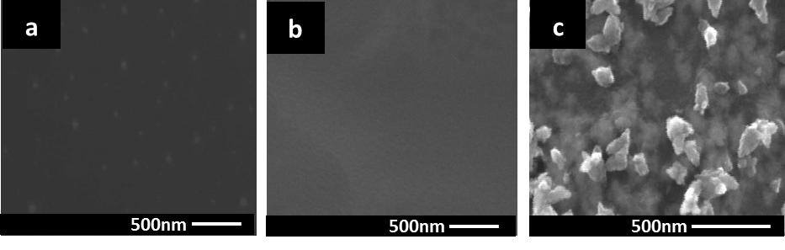

**Figure 2.**

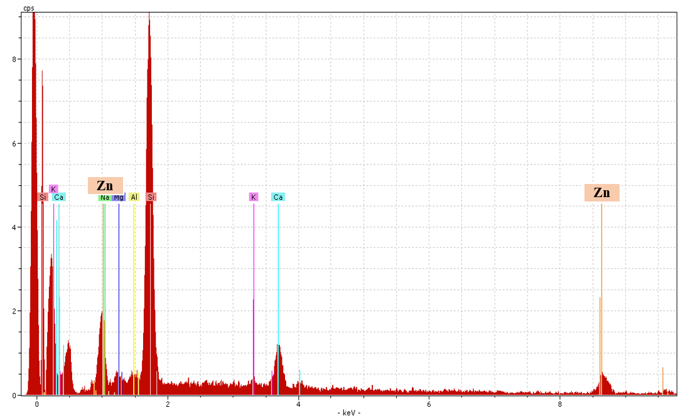

**Figure 3.**

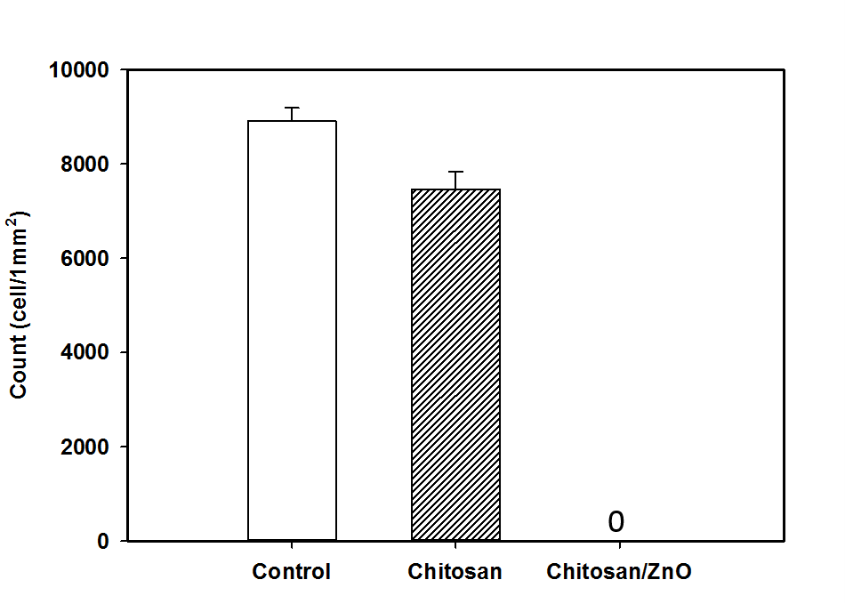

**Figure 4.**

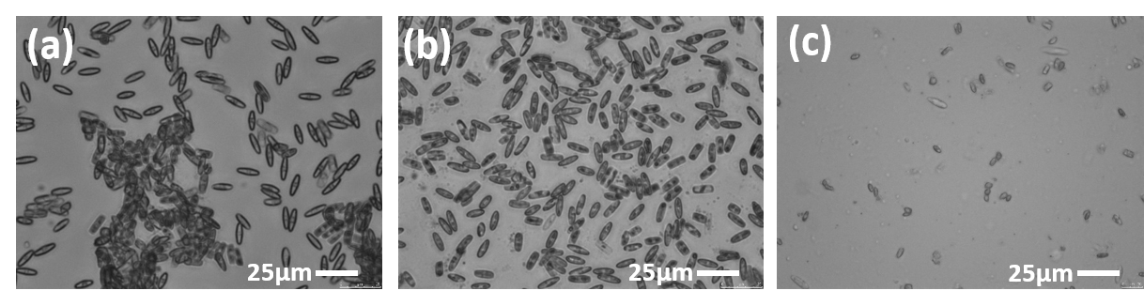

**Figure 5.**

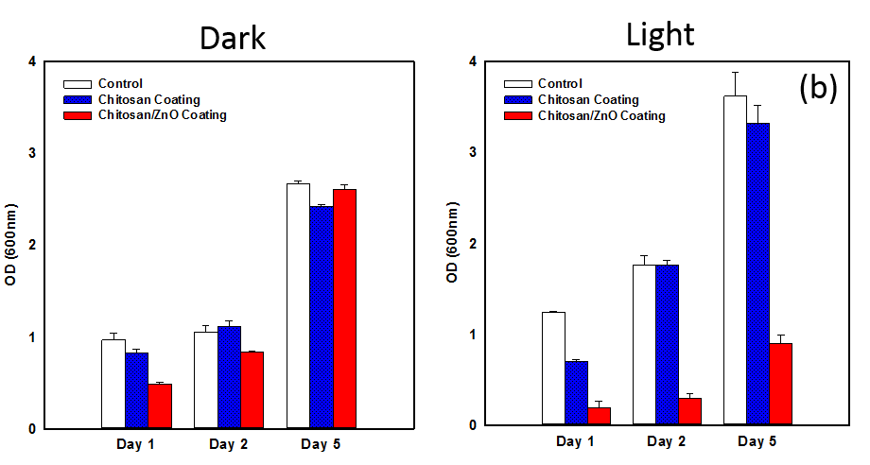

**Figure 6.**



**Figure 7.**

C:\Users\lnaamani\Desktop\Antifouling paper\Results\fluor results-sybr.tif

**Figure 8.**



**Figure 9.**

**Table 1. Measurement of static water contact angle of chitosan-ZnO coating in comparison with chitosan coating. The data are mean +-standard deviations of three replicates (p < 0.05).**

|  |  |  |  |  |  |
| --- | --- | --- | --- | --- | --- |
| **Sample** | **Reading Time** | **Working solution** | | | |
| **Milli-Q water** | | **Sea water** | |
| Contact Angle | Surface Energy | Contact Angle | Surface Energy |
| **Chitosan coating** | 0min | 50.5±4.6 | 53.4±2.6 | 50.9±4.3 | 52.6±3.5 |
| 5min | 39.2±1.9 | 59.8±1.0 | 39.9±2.4 | 59.4±1.3 |
|  |  |  |  |  |  |
| **Chitosan-ZnO coating** | 0min | 60.0±1.2 | 47.8±0.7 | 62.9±2.7 | 46.1±1.7 |
| 5min | 54.9±1.0 | 50.9±0.6 | 57±1.8 | 49.6±1.1 |

**Table 2. Swelling and solubility properties of chitosan coating and chitosan-ZnO composite coating on glass slides. Different numbers in the same column indicate significant differences (p < 0.05).**

|  |  |  |  |  |
| --- | --- | --- | --- | --- |
|  | **Swelling ratio** | | **Film solubility** | |
| % | SD | % | SD |
| Chitosan coating | 1.531 | ±0.37 | 0.961 | ±0.26 |
| Chitosan-ZnO coating | 0.492 | ±0.22 | 0.372 | ±0.01 |