Scale-up of Batch Rotor-Stator Mixers. Part 2 – Mixing and Emulsification
J. Jamesª, M. Cookeª, A. Kowalski^{b}, T. Rodgers^{a,*}
ªSchool of Chemical Engineering and Analytical Science, The University of Manchester, Manchester, M13 9PL, UK
^{b}Unilever R&D, Port Sunlight Laboratory, Quarry Road East, Bebington, Wirral, CH63 3JW, U.K

*Corresponding author. Email address: tom.rodgers@manchster.ac.uk

Abstract
Rotor-stator mixers are characterized by a set of rotors moving at high speed surrounded closely by a set of stationary stators which produces high local energy dissipation. Rotor-stator mixers are therefore widely used in the process industries including the manufacture of many food, cosmetic and health care products, fine chemicals, and pharmaceuticals. This paper presents data demonstrating scale-up rules for the mixing times, surface aeration, and equilibrium drop size for Silverson batch rotor-stator mixers. Part 1 of this paper has already explored scale-up rules for the key power parameters. These rules will allow processes involving rotor-stator mixers to be scaled up from around 1 litre to over 600 litres directly avoiding problems such as surface aeration.

Graphical abstract
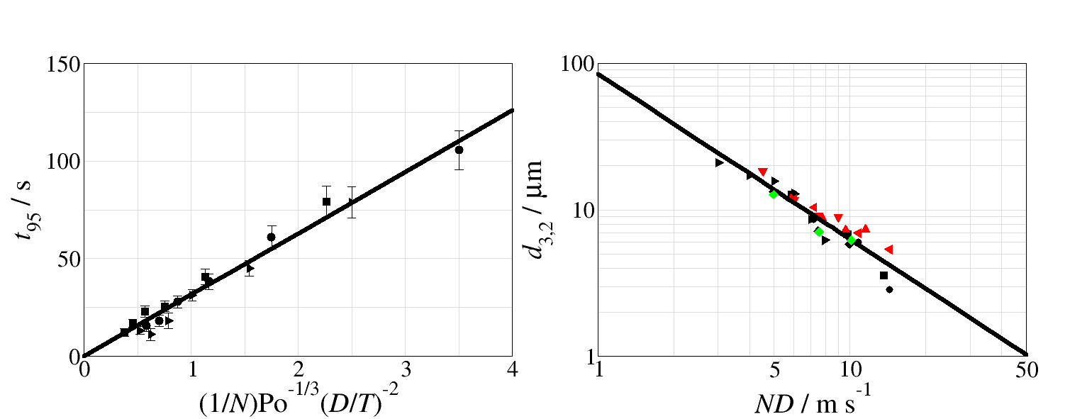

Highlights
- Batch rotor-stator mixing time can be given by $t_{95}N=31.5{\text{Po}}^{-1/3}{\left(D/T\right)}^{-2}$
- Removing the screens reduces the mixing time
- The flow patterns created by rotor-stator mixers are mainly radial, but baffles in the vessel reduce any swirl flow
- The onset of surface aeration for the rotor-stator is given by ${\text{Fr}}_{s}=18.73D^{0.06}$
- The equilibrium drop size can be given by $d_{3,2}=84.3{\left(ND\right)}^{-1.125}$ for rotor-stator systems with or without screens

Keywords
Batch rotor-stator mixers, mixing time, emulsification, scale-up

Introduction
Rotor-stator mixers are characterized by a set of rotors moving at high speed surrounded closely by a set of stationary stators (or screens). The rotors generally rotate at an order of magnitude higher speed than conventional impellers in a stirred tank; typical tip speeds range from 10 to 50 m s^{–1} with the gap between the rotors and stators generally ranging from 100 to 3000 μm. This design allows the generation of high shear rates and high intensities of turbulence. The energy generated by the rotor dissipates mainly inside the stator and therefore the local energy dissipation rates are much higher than conventional impellers in stirred vessels (Atiemo-Obeng and Calabrese, 2004).
Part 1 of this paper examines the power constants for scale-up of batch Silverson rotor-stator systems. The laminar power and Metzner-Otto constants were found to scale simply by a power law with the stator diameter. The turbulent power numbers scaled by expressions similar to inline rotor-stator system in the form of Po=Po_{z}+kN_{Q}. For the system with the stator the flow number could be shown to be related to the flow area such that the power number could be represented by,
$${Po}_{T}=1.60{\left(\frac{min\left(h_{r}\right)}{D}\right)}^{2}+1.20$$ | (1)
This paper continues by examining other aspects which are important to scale-up batch rotor-stator mixers such as the mixing time and emulsification properties.
As the time taken for a vessel to mix two or more components together is crucial to many processes, a lot of work has gone into trying to predict this time from knowledge of the agitator and the operating conditions. Many different methods of determining the mixing time have been used; e.g. dye addition (Mann et al., 1987), pH shift (Singh et al., 1986), tracer monitored by conductivity probes (Ruszkowski, 1994), Flow followers (Bryant and Sadeghzadeh, 1979), and Electrical Resistance Tomography (Rodgers and Kowalski, 2010). The dimensionless mixing time has been shown to be a function of the Reynolds number, the agitator power number, the Froude number, and geometric parameters such as D/T , H/T , etc.
The turbulent regime is the most studied regime in the literature, with many correlations being presented for the dimensionless mixing time as a function of these parameters. In the turbulent regime in a fully baffled vessel, the dimensionless mixing time is independent of the Reynolds number and the Froude number.
Grenville and Nienow (2004) suggest that for a wide variety of impellers and aspect ratios, with a liquid height equal to or less than the tank diameter, the dimensionless mixing time can be given by equation (2), where D is the impeller diameter, N is the rotor speed, T is the tank diameter, and H is the liquid height, t₉₅ is the 95% mixing time, and Po is the power number.
$$t_{95}N=5.2{\text{Po}}^{-1/3}{\left(\frac{D}{T}\right)}^{-2}{\left(\frac{H}{T}\right)}^{1/2}$$ | (2)
This expression was extended by Rodgers et al. (2011) for a number of impeller systems for liquid heights greater than the tank diameter as equation (3), when the constant β is dependent on the impeller type.
$$t_{95}N=5.2{\text{Po}}^{-1/3}{\left(\frac{D}{T}\right)}^{-2}{\left(\frac{H}{T}\right)}^{β}$$ | (3)
It is interesting to note that this equation can be written as equation (4), where Fo is the Fourier Number (µt₉₅/ρT²).
$$\text{Re}{\text{Po}}^{-1/3}\text{Fo}=5.2{\left(\frac{H}{T}\right)}^{β}$$ | (4)

A typical method of benchmarking mixing systems as well as mixing time is examining the drop size of emulsions produced; this is because dispersed fluid systems are present in many industrial applications. One of the most important characteristics of a dispersed system is its particle size, since it determines or affects many of the system’s physical and chemical properties. The particles in the system are made of different sizes and have a drop size distribution which is typically characterised by the Sauter mean diameter, d_{3,2}.
Often droplets are thought to break-up due to turbulent eddies, i.e. energy dissipation rate. Break-up due to turbulent eddies is generally based on the work of Kołmogorov (1949) and Hinze (1955) which utilize the concept of eddy turbulence to define a limiting drop size. It is usually assumed that drop break-up occurs due to the interactions of drops with the turbulent eddies of sufficient energy to break the drop (Liao and Lucas, 2009). For a given fluid system the effective equilibrium drop size (this is the drop size after a sensible processing time, when the drop size reduction with time is very small and almost unmeasurable) is dependent on the maximum local energy dissipation and thus should scale-up with this value when using geometrically similar vessels. For low viscosity dispersed phase dilute liquid–liquid systems, the drops are inviscid as the internal viscous stresses are negligible and only the interfacial tension force contributes to stability. The maximum stable equilibrium drop size, d_{max}, can be related to the maximum local energy dissipation rate, ε_{max}, by Equation (5) for isotropic turbulence (Davies, 1987).
$$d_{\text{max}}=C_{1}{\left(\frac{σ}{ρ}\right)}^{3/5}{ϵ_{\text{max}}}^{-2/5}$$ | (5)
For turbulent flow conditions, using geometrically similar systems, Equation (5) has been rearranged into a dimensionless form, in terms of d_{3,2} (which is typically reported to be proportional to d_{max}) and using the Weber number, such that,
$$\frac{d_{\text{3,2}}}{D}=C_{2}{\text{We}}^{-3/5}$$ | (6)
Calabrese et al. (2000) applied Equation (6) to correlate the drop size in a batch Ross rotor–stator mixer and reported a constant of 0.040. Another typically used scale-up method for emulsification in stirred vessels is tip speed, ND, of the rotor or impeller (El-Hamouz et al., 2009),
$$d_{\text{3,2}}=C_{3}{\left(ND\right)}^{C_{4}}$$ | (7)
Break-up due to the agitator shear rate is based on a balance between the external viscous stresses and the surface tension forces (Liao and Lucas, 2009). If the break-up is due to the agitator shear rate then the effective equilibrium drop size is related to the maximum shear rate. This would mean that lower power number agitators can produce smaller drops than higher power number agitators, as low power number agitators may have a higher shear rate. This has been seen experimentally (Zhou and Kresta, 1998); when scale-up is performed on a constant energy dissipation rate, smaller drops are observed at larger scales (Bałdyga et al., 2001). This is likely due to the shear rate increasing at larger scales when the energy dissipation rate is kept constant (Rodgers and Cooke, 2012a).
Rueger and Calabrese (2013a, 2013b) have recently looked at the dispersion of water in an oil continuous phase at a variety of concentrations with batch rotor-stator devices and found good correlation with ReWe. Zhang et al. (2012) provide a further review of high-shear mixers.

Material and methods

Experimental equipment
Figure 1 provides photos of the three experimental rig used for these experiments. They all consist of a circular flat bottomed vessel, with liquid height equal to the diameter of the vessel. The batch rotor-stator is positioned in the centre of the vessel at a height equal to half the liquid height. Each vessel was also baffled with four standard T/10 baffles. The largest vessel is fitted inside a square jacket through which water can be circulated for temperature control. The square jacket also provides distortion free viewing windows for flow visualisation.
The smallest scale consists of a 0.128 m diameter vessel with a Silverson L5M rotor-stator mixer, this device had both the standard Emulsor screen mixing head and the 5/8” Micro tubular mixing head; this system had a TorqueSense 1 Nm torque meter attached to allow calculation of the power. The rotor speed range is 0 to 10,000 rpm, controlled by the internal bench unit system. The middle scale consists of a 0.380 m diameter vessel with a Silverson AX3 rotor-stator mixer, which was used with the standard Emulsor screen; this system had a TorqueSense 5 Nm torque meter custom installed in the motor housing by Silverson. The rotor speed range is 0 to 3000 rpm, controlled by an inverter over the range 0–50 Hz. The largest scale consists of a 0.6096 m diameter vessel with a Silverson GX10 rotor-stator mixer, this device had a 4.5” Emulsor screens rotor-stator mixing head and a 5.8” Emulsor screens rotor-stator mixing head, which also had a custom large hole screen; this system had a TorqueSense 40 Nm torque meter custom installed in the motor housing by Silverson. The rotor speed range is 0 to 3,000 rpm, controlled by an inverter over the range 0–60 Hz. The vessel is also fitted with 8 rings of 16 equally spaced EIT electrodes (6 rings below the liquid height) in a baffle cage configuration which are connected to an ITS P2000 tomography measurement system. Details of the rotor stators are provided in Table 1.
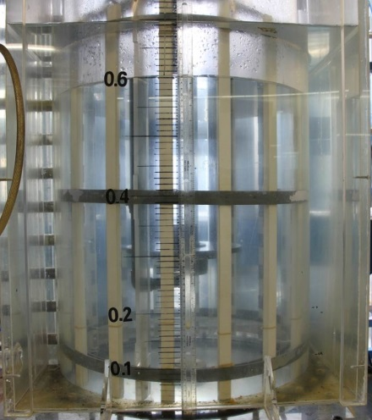 | 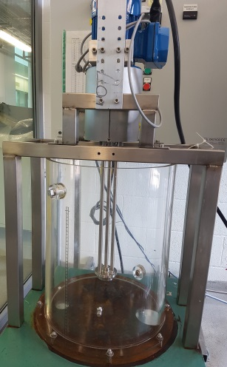 | 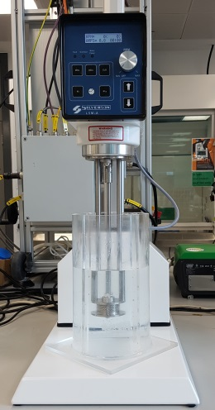
(a) | (b) | (c)
Figure 1. Photos of the 3 three systems used, (a) GX10, (b) AX3, and (c) L5M.
Impeller | Rotor Diameter (mm) | Blade Height (mm) | Vessel Diameter (mm)
GX10 5.8” | 149.23 | 34.87 | 609.60
GX10 4.5" | 114.30 | 23.82 | 609.60
AX3 standard | 50.55 | 11.10 | 380.00
L5M standard | 31.71 | 12.64 | 128.00
Table 1. Dimensions of the Silverson mixers used in this study.

Mixing Time Measurements
Experiments for the mixing times were carried out by adding a brine solution (50 g table salt dissolved per litre of tap water) to the surface of the liquid. For visualisation runs the tracer was also dyed with 50 g per litre water soluble Nigrosine dye (Fisher). The brine solution was added to the vessel in small aliquots onto the surface in a fixed position 2/3 of the radius from the agitator shaft and between two baffles. The energy input of the addition was small compared to that given by the agitator. The mixing times were calculated over a range of agitation rates and several repeats were taken for each speed.
Electrical impedance tomography (EIT) is commonly used to monitor processes which require good temporal and spacial resolution. It has been used to measure mixing times in industrial single phase and multi-phase systems (York, 2001). The ITS P2000 was chosen for the experiments presented in this paper as it is the best performing EIT instrument, available to us, for experiments requiring high temporal resolution and is capable of successfully monitoring homogeneity. The signal-to-noise ratio (SNR) was checked to ensure that no voltage measurements were saturating the analogue to digital converter. The optimum injection current was found to be 50 mA resulting in a SNR ratio of approximately 59 dB for water at the start of the experiment. The SNR is the ratio of the mean of one voltage reading over a number of frames, n, to the standard deviation of the reading, averaged over the number of readings in a frame.
The mixing time was analysed by considering the time taken for the system to return to homogeneity after the step change addition of the salt solution. Since the measurements were collected using EIT, the change in collected voltages can be used to monitor this return. The advantage of this method is that multiple measurements are taken, but does not introduce any error in the measurements due to reconstruction. The extent of homogeneity is tracked using of the log of the root mean squared. The analysis was carried out by evaluating the change of measurement from the start, relative to the difference between the initial and final readings, these values are then normalised for the number of measurements, equation (8),
$$\ln\left[V_{rms}\right]=\frac{1}{2}\ln\left[\frac{1}{N}\sum_{i=1}^{N}{{\left(\frac{V_{t,i}-V_{0,i}}{V_{∞,i}-V_{0,i}}-1\right)}^{2}}\right]$$ | (8)
where V represents the voltages, N is the number of measurements, and the subscript t, 0 and ∞ represent the value of measurement i at time equals t, the start time and the end time. It can be seen that due to the nature of the equation a system can be said to be 90% homogeneous when ln[V_{rms}] drops below –2.3, however since most literature values are provided for 95% mixing time, the value attained can be scaled to a 95% time; as $t_{95}=t_{90}{\text{ln}\left(1-0.95\right)}/{ln⁡\left(1-0.9\right)}$. This is valid if the mixing follows an approximate exponential decay, i.e. ln[V_{rms}] reduces linearly with time. Figure 2 shows an example trace for the log root mean squared voltage, the start time is when the tracer is added and the end time is when the value of the log root mean squared voltage never exceeds -2.3. The advantage of this analysis method is that equation (8) biases the result towards the values that change slowest, which gives a better representation of the end point of the process.
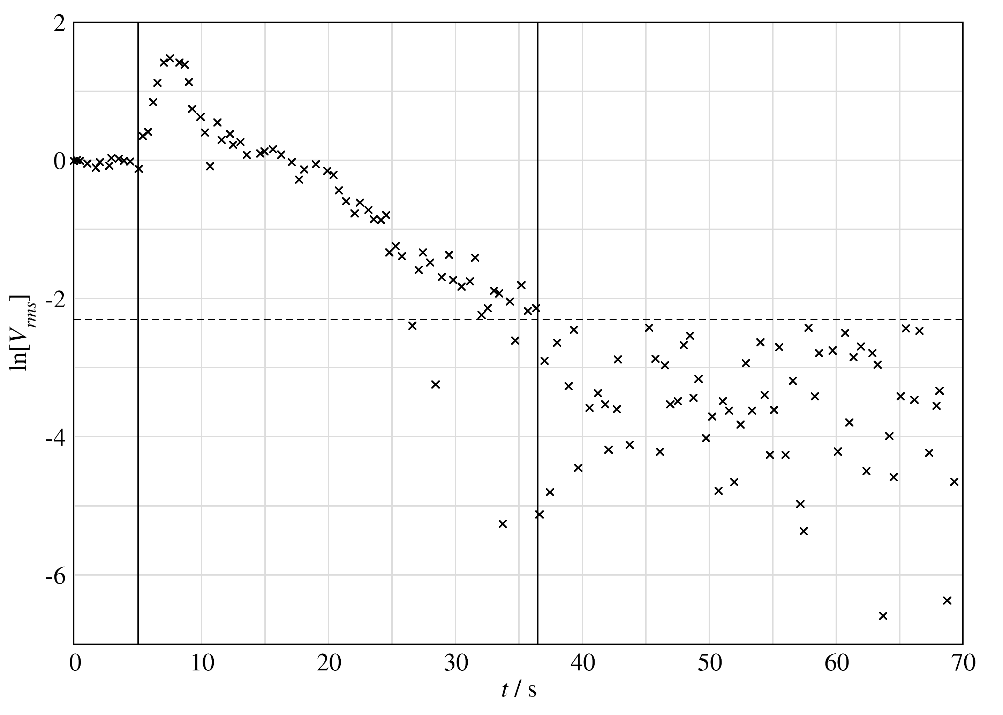
Figure 2. Example variation of log root mean square voltage variation with time for the GX10 5.88” rotor-stator at 800 rpm.

Flow Pattern Determination
Identifying the flow pattern was undertaken by using two different methods; tomography and visual identification. An accurate geometric model of the vessel, including the exact electrode positions, was developed using constructive solid geometry. The baffles and the agitator were also modelled as they strongly affect the measured voltage signals (Stephenson, 2008) and so are requisite for the finite element model accuracy (Rodgers and Kowalski, 2010). The geometric model was meshed (using an advancing front surface mesh and Delaunay techniques) to give tetrahedral elements using the Netgen mesh generator (Schöberl, 1997). The collected voltage data was reconstructed using a generalised singular value decomposition (gsvd) algorithm (Hansen, 1989) based on the finite element model. This approach decomposes the image into individual spatial frequency components and affords the ability to control the number of generalised singular values incorporated into the solution. The inclusion of a low number of singular values in the solution yields an image with lower spatial resolution but which is robust to measurement noise. Conversely, the inclusion of a high number of singular values yields an image with potentially higher spatial resolution which is less robust to measurement noise. The regularisation parameter in the algorithm was chosen frame by frame to be the value obtained by an analysis of the Discrete Picard Condition (Hansen, 1990). The Discrete Picard Condition compares the generalised singular values (representing the change in the data) with the Picard coefficients (representing the noise in the data), and gives the value where they are equal. Values of the generalised singular values greater than the Picard coefficients contain recoverable data and should be utilised, which occurs if the regularisation parameter is set to this equality (Rodgers and Kowalski, 2010). The regularisation parameter varies with the frame number; during the mixing the regularisation parameter increases as the sharp changes in conductivity create more noise in the data.
For visual identification the mixing tracer with dye was filmed and then the individual frames were extracted.

Emulsification
For all cases a 1 wt% 10 cSt silicone oil (poly-dimethyl siloxane, Dow Corning 200 fluid) and 0.5 wt% sodium laureth sulfate (SLES 2EO, Texapon N701) in water solution were used. The SLES surfactant was a commercial grade supplied as a 70 wt% active viscous yellow liquid.
The SLES surfactant was added to tap water and mixed for each system until it was apparent it had visibly dissolved. After this the silicone oil was added to the vessel and mixed at the relevant agitation speed for 30 minutes. This time was selected as transient measurements had determined that this was the period of time needed to produce the equilibrium drop size. After this time samples of the resulting emulsion were collected.
A Mastersizer M3000 laser diffraction particle analyser (Malvern Instruments, Malvern, UK) was used to measure the drop size distributions of the samples. Samples were diluted in water/SLES solution to ensure the oil droplets were dispersed in a medium similar to the continuous phase, and to prevent coalescence and oil deposition on the optical windows of the sample cell, this produced an obscuration rate between 7–14%. Each sample was analysed 5 times by the instrument. The relative refractive indices (RI) used were 1.33 for the continuous water phase, and 1.42 for the silicone oil dispersed phase. The imaginary component of the absorption index for silicone oil was taken as 0.001. The Mastersizer’s software configuration was set to General Analysis model allowing for multiple modes if needed. The value of the obscuration, absorption index, and relative refractive indices were tested to make sure they didn’t affect the drop size distribution; they didn’t over any sensible range of variation. Emulsion samples measured directly after production were found not to change over 48 hours. For consistency, samples were measured within 24 hours after the experiment was completed. The distributions produced were mono-modal and fit to a simple log-normal distribution.

Results and Discussion

Mixing Times
The mixing times were plotted against impeller speeds, giving an inverse relationship, as expected for turbulent mixing; however, initial results indicated that the mixing times were significantly slower than predicted by the Grenville equation (Grenville and Nienow, 2004), equation (2), but the general trend matched this relationship. On the basis that the mixing constant, α, was the only variant, the data was fitted to find a new constant for the rotor stators, equation (9).
$$t_{95}N=α{\text{Po}}^{-1/3}{\left(\frac{D}{T}\right)}^{-2}$$ | (9)
Figure 3 shows the result for the rotor-stator heads from the GX10 and L5M. The results show that a new constant to 31.5 fits the data collected from the rotor stator for all sizes, shown by the black diagonal line. This is roughly 6 times higher than the Grenville constant (5.2), indicating that mixing carried out by the rotor stator is 6 times slower than by equivalent non-stator impellers. It should be noted that although the mixing is slower than a conventional impeller at the same speed, rotor-stators are typically run at a much higher speed so the actual mixing times are similar.
The reason for this slower time is most likely due to the presence of the stator, and the restricted flow through the holes. To check this the mixing time experiments were repeated with the screens with larger holes (which has been seen to increase the power number, James et al. (2016)) and with the screens removed. It can be seen from Figure 3 that these modification do improve the mixing efficiency.
Increasing the size of the stator holes to 5mm for the 5.88” rotor-stator increases the power number from 1.25 to 1.63, which is due to an increased flow rate, this reduces the α constant value to 13.1, shown as the blue line. Removing the screen completely reduces the α constant value further to 10.5, shown as the red line, this is due to a further increase in the flow rate from the rotor. The efficiency of the rotor is not as efficient as a regular impeller (α = 5.2); in fact it is approximately double, this may be due to the large base plate, which is approximately 47% of the diameter of the vessel, dividing the flow of the vessel into two zones, a top zone (above the plate) and a bottom zone (below the plate).
A common variation of the system to improve the mixing is the addition of a second impeller to provide the bulk mixing. In this case a 6” diameter 3 blade propeller was added to the same shaft as the rotor-stator at a depth from the liquid height of 0.15 m. The power number for this combined system based on the diameter of the rotor (0.1143 m) is 2.94. In this case the α constant value was reduced to the same value as for the stator without the screen, 10.5.
It is interesting to note that although the two different methods were used to improve mixing, the results obtained give the same efficiency. It can be deduced from the results that there exists a possible maximum mixing rate that can be provided by the rotor stator, which is twice as slow as by any equivalent impeller (at the same speed).
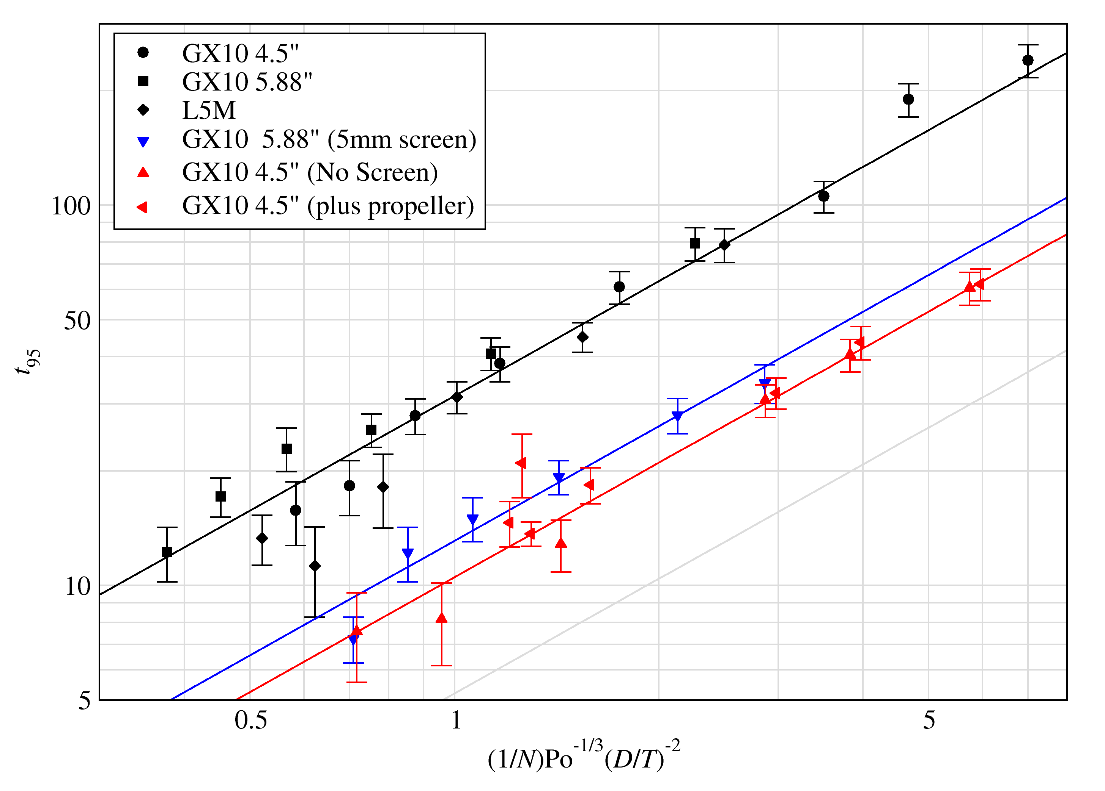
Figure 3. Variation of the mixing time for the systems studied in this paper. The grey diagonal line represents the position of the Grenville equation, Equation (3).
For the system with the added propeller, the higher speeds caused surface aeration to occur, in some cases air was draw into the system causing the liquid height to increase and the power number of the system to drop (up to 25% by 2000 rpm – though mostly a drop in the power number of the propeller). The power was measured for each of the mixing runs so the actual values could be used, and a modified version of equation (9) was used for the speeds over 1000 rpm,
$$t_{95}N=10.5{\text{Po}}^{-1/3}{\left(\frac{D}{T}\right)}^{-2}{\left(\frac{H}{T}\right)}^{2}$$ | (10)
which is a similar but slightly higher exponent than for the mixed flow impeller seen by Rodgers et al. (2011).

Surface Aeration
In addition, an observation made during the operation of the impellers found that both methods of improving the mixing, lead to a decrease in the operational range of the impeller, this is due to an early onset of surface aeration. Surface aeration was observed in all impellers at various speeds and the results obtained using water is shown in Figure 4. The correlation for this can be given by,
$${\text{Fr}}_{s}=18.73D^{0.06}$$ | (11)
which has an exponent on the diameter less than that seen by Veljković et al. (1991) but similar to that seen by Matsumura et al. (1978) for 6 blade turbines. Removing the screens reduced the rotor speed for the onset of surface aeration. The use of the propeller caused even more surface aeration which reduces the proportionality constant in equation (11).
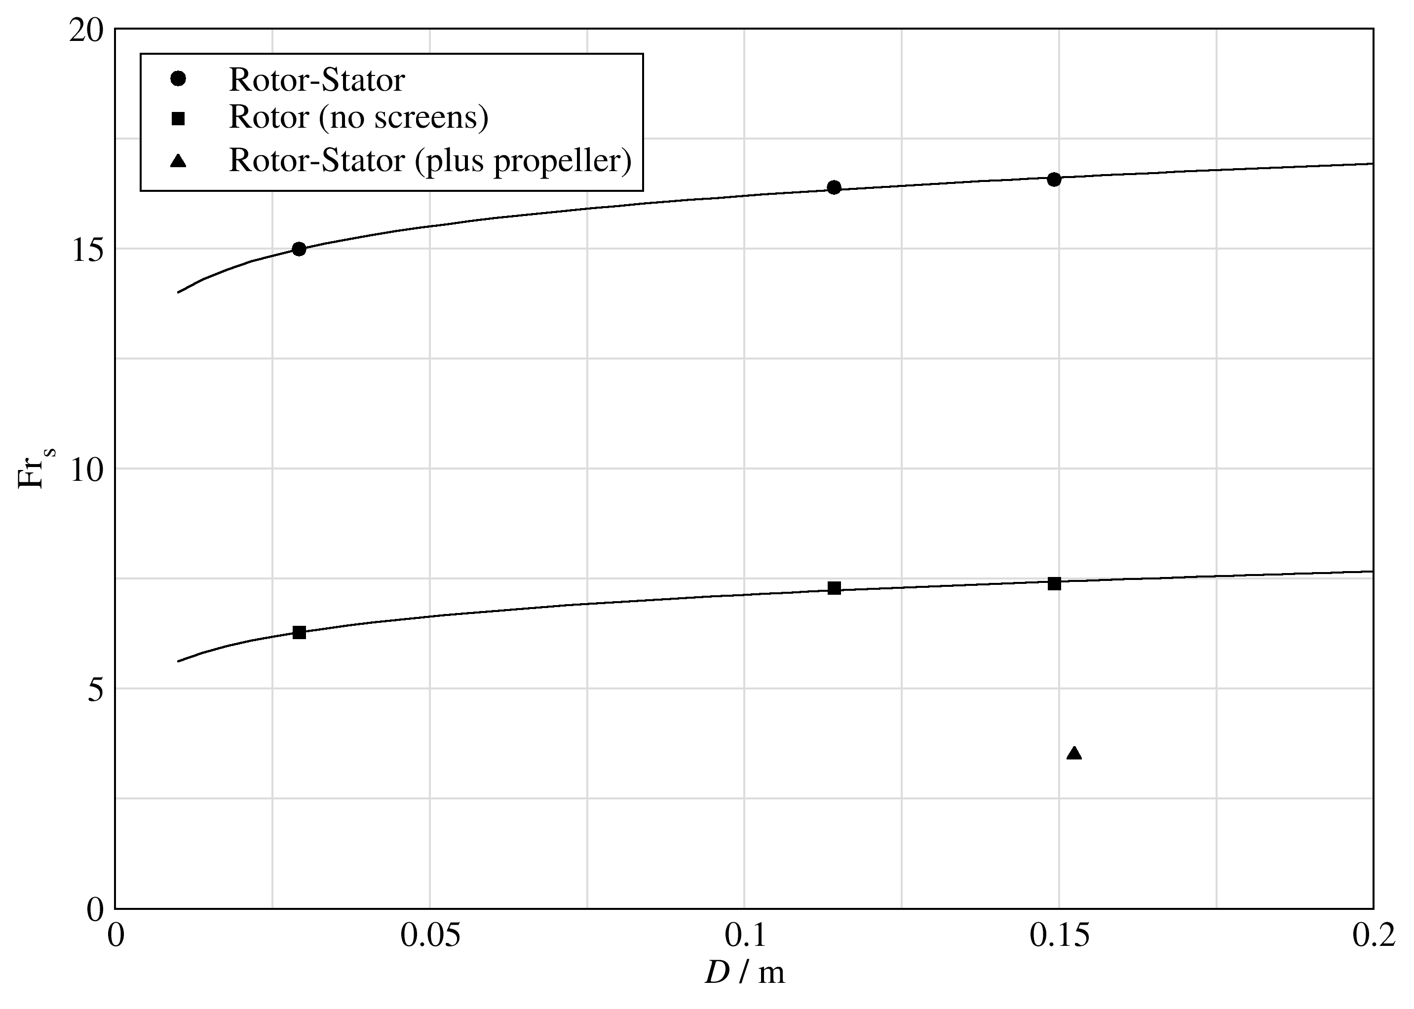
Figure 4. Froude number (Fr_{s}) at onset of surface aeration for the systems studied in this paper.
When the propeller is in motion, there are strong turbulent flows within the liquid; this causes surface aeration to occur at much lower speeds. Similarly when the stator is removed, the turbulence of the system increases, allowing air entrainment to occur at much lower speeds. From the results and in combination from the results of the mixing times, it can be seen that using the rotor stator with the propeller improves mixing time greatly, but reduces the operational envelope to a maximum of 900 RPM. The reduction in operation envelope is also true for the removal of the stator. Figure 5 shows photographs of surface aeration occurring due to the addition of the propeller and the level of gas entrainment seen at higher speeds.
It is also interesting to note that surface aeration was observed within silicone oil as surface aeration occurring within silicone oil manifests itself in a similar but more interesting manner as shown in Figure 6. Surface aeration within silicon oil is manifested as small rings forming on the impeller shaft near the surface, as the speed is increased further, the number of rings increases, until eventually the bubbles are dragged down the surface of the shaft and into the rotor-stator.
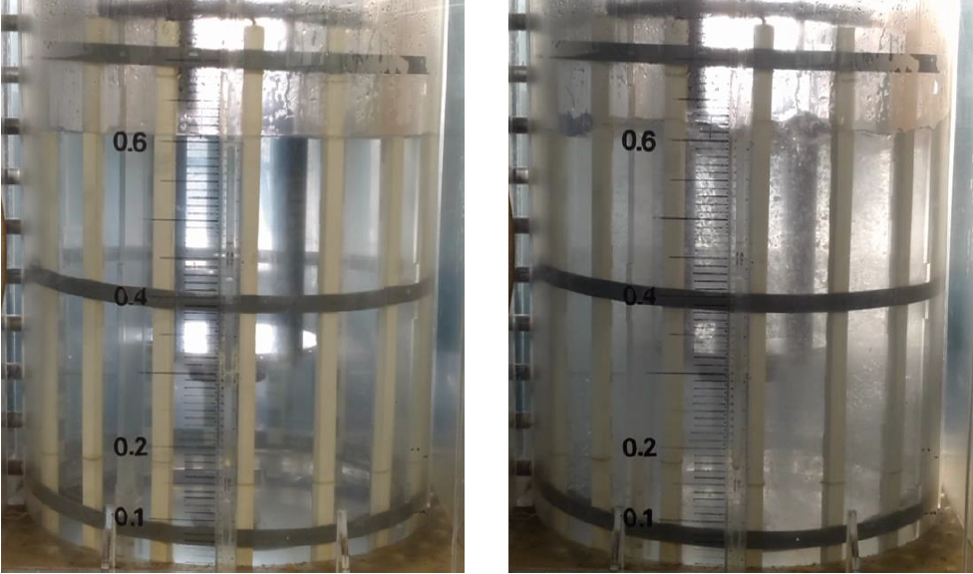
(a) 600 rpm | (b) 1000 rpm
Figure 5. Photo of air entrainment for the rotor-stator with the propeller system, (a) before onset of surface aeration, (b) after onset of surface aeration.
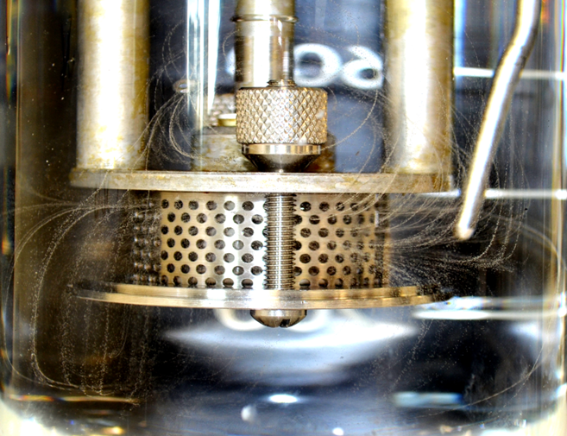
Figure 6. Entrained small air bubbles dragged down the shaft and recirculated through the rotor-stator in high viscosity 1000 cSt Silicon oil.

Flow Patterns
The flow pattern identification was carried out on the large scale GX10 with the 0.1143m rotor stator using two methods, the use of a water soluble dye as well as through the use of ERT. Dye and salt (ERT tracer) were added to the surface of the tank. The images obtained by the use of tomography and dye addition is shown in Figure 7, the red shows area of high conductivity, i.e. the salt that has been added.
By analysing the reconstruction and the photographs, a strong radial mixing can be identified. The tracer that is added flows directly down towards the impeller, as soon as the solution nears the impeller, the path of the tracer is modified and is forced towards the wall (d) – (f). After a few seconds the tracer starts to circulate in a pattern that is very closely identified to a radial mixing pattern. It must also be highlighted that the ERT and the photographs indicate that there are areas of poor mixing, particularly the area behind which the tracer has been added. From the fact there is very little interruption in the direction of flow initially, it can be deduced that the flow pattern does not strongly dominate the whole tank and the base plate that is present plays a role in limiting the flow pattern, especially in the top of the vessel. Although there is radial mixing, there is a lack of swirl flow. It can be speculated that the lack of swirl flow is most likely due to the presence of the baffles.
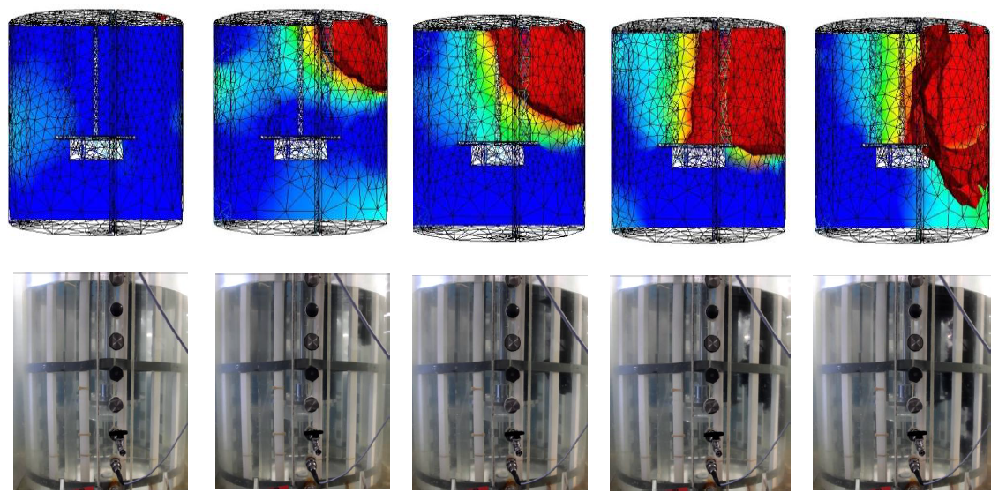
- 0 s | - 1 s | (c) 2 s | (d) 3 s | (e) 6 s
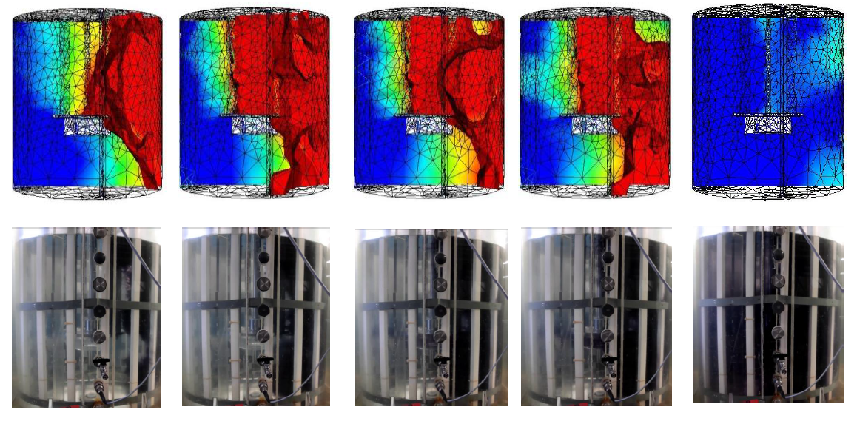
(f) 14 s | (g) 19 s | (h) 24 s | (i) 29 s | (j) 40 s
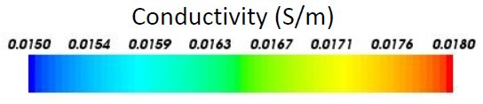
Figure 7. Flow pattern shown for reconstructed EIT data, top row, and photos of the dye addition, bottom row, for the 4.5” rotor-stator at 400 rpm.
The results of the flow pattern generated with the use of the propeller are shown in Figure 8. It is easy to see that by using the propeller, the area of poor mixing has been clearly eliminated and as a consequence the mixing occurs much faster. It is also interesting to see that when the dye is initially added to the surface, it is pulled down by the propeller (c)-(e), which dominates the mixing on the top half of the tank. Once the dye reaches the base plate (h), it enters the radial pattern of the rotor stator and the bottom half of the tank is then mixed.
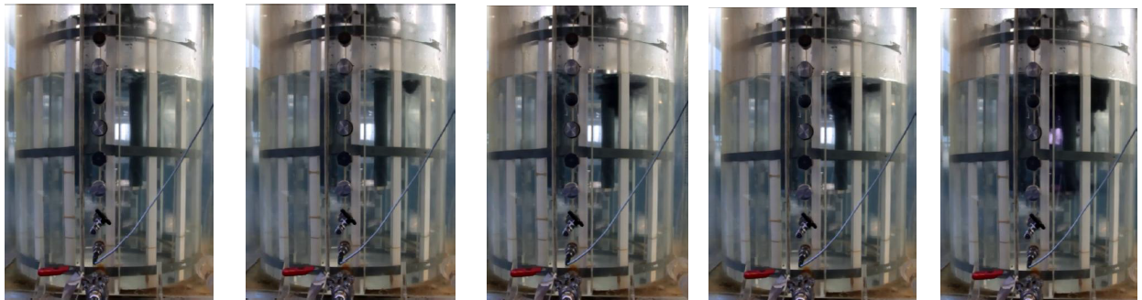
(a) 0 s | (b) 1 s | (c) 20 s | (d) 23 s | (e) 25 s
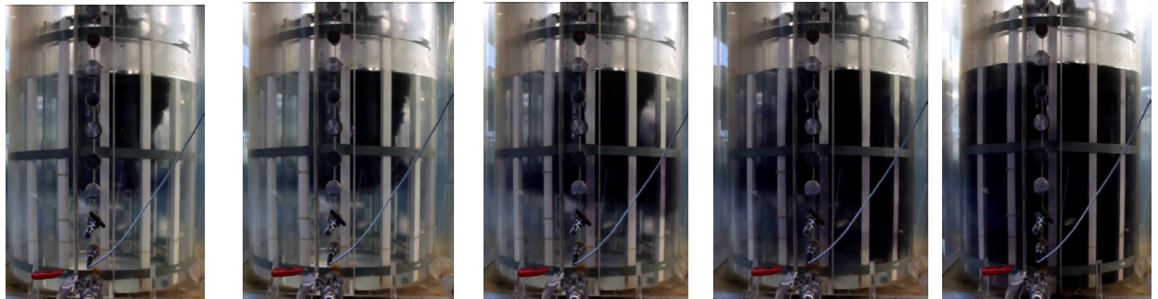
(f) 29 s | (g) 33 s | (h) 35 s | (i) 44 s | (j) 50 s
Figure 8. Flow pattern shown for photos of the dye addition for the 4.5” rotor-stator with the propeller at 200 rpm.

Drop Breakage
The equilibrium drop sizes measured at different agitation rates for the different scales of rotor-stator used can be seen in Figure 9. Figure 9(a) is the variation with the tip speed (ND) while Figure 9(b) is the variation with the maximum energy dissipation, i.e. the power divided by the volume of the rotor, which is typical for rotor-stator mixers; this gave a better fit of the data than the power divided by the whole tank volume.
These equilibrium drop sizes can be seen to vary with the tip speed of the rotor (ND) regardless of the scale of the rotor-stator device. This equilibrium drop size can be given by,
$$d_{3,2}=84.3{\left(ND\right)}^{-1.125}$$ | (12)

These drop sizes can be compared to those produced by the rotor with the screens removed and with the propeller added (i.e. the methods used to reduce the mixing time). It can be seen from Figure 9 that these equilibrium drop sizes line on the same line as those created with the rotor-stator system. This agrees with results generated by Rodgers and Cooke (2012b) who showed that emulsions created with an in-line rotor-stator were the same size with and without the screens. This is most likely due to the fact that the emulsion breakage is dominated by the rotor, rather than the stator. These results are only valid for low phase fraction emulsions were coalescence doesn’t play a role, if coalescence occurs within the system, e.g. for high phase fractions, a different behaviour may be seen.
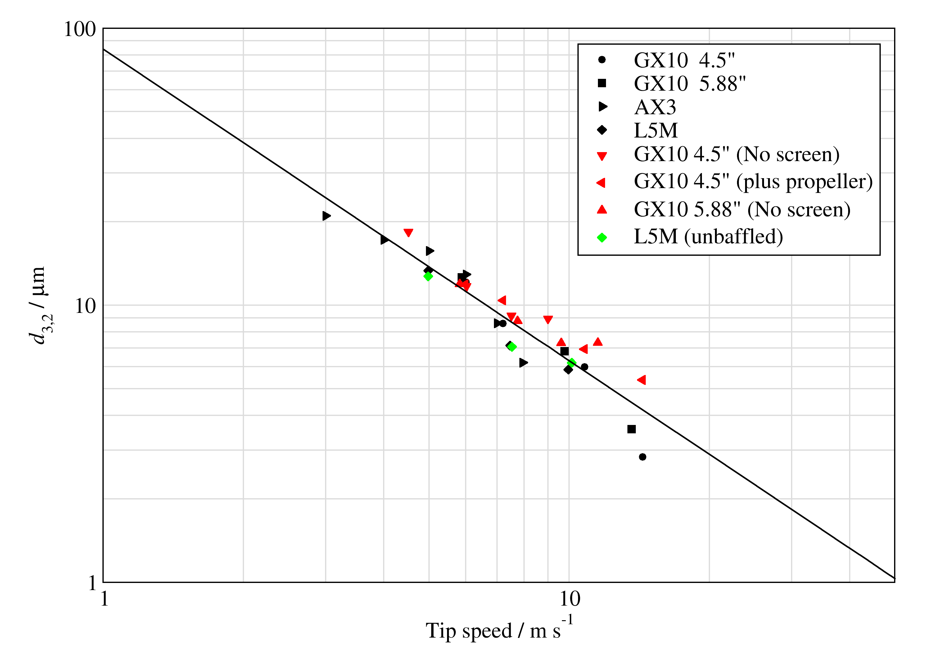 | 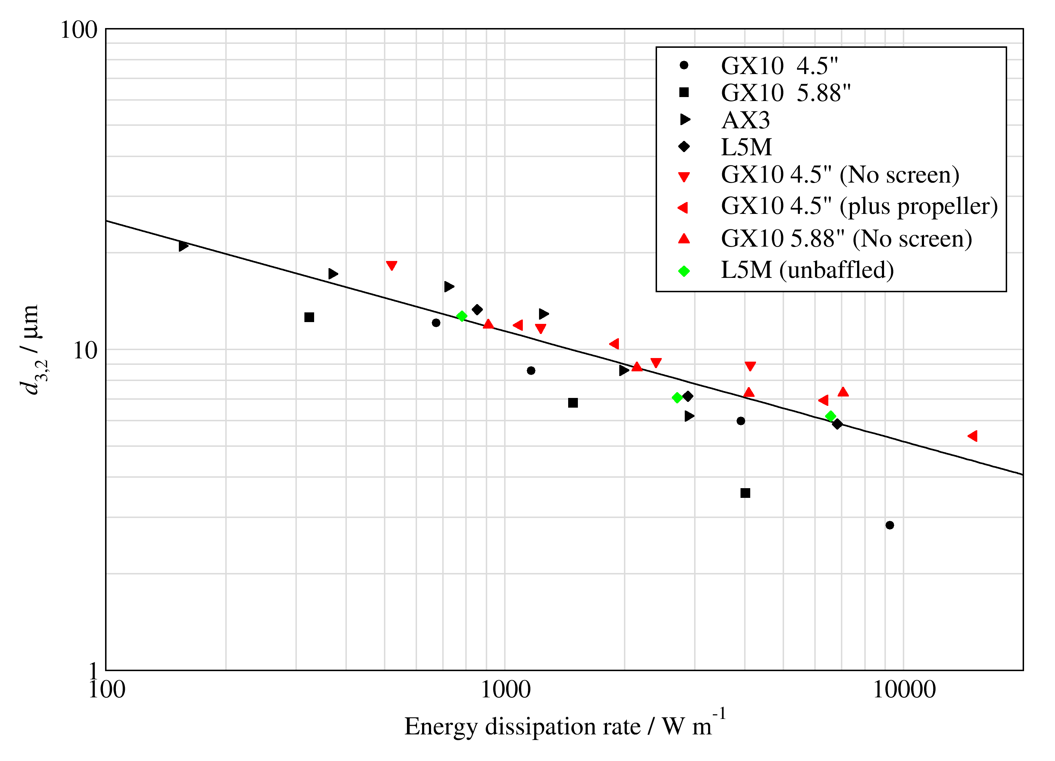
(a) | (b)
Figure 9. Variation of drop size for 10 cSt silicon oil after 30 minutes of emulsification plotted against (a) tip speed and (b) energy dissipation rate.
Hall et al. (2011) examine the scale-up of emulsification using inline Silverson rotor-stators and see a similar effect with tip speed and energy dissipation. They state that tip-speed is a better scale-up parameter than the energy dissipation although the smaller mixer consistently produced slightly smaller drops at equal tip speeds. The exponent on the tip speed was found to be –1.2 for 10 cSt silicon oil, which is similar to the value found here. They found that the Weber number was the best scaling parameter; however, never changed the interfacial tension during the experiments.

Conclusions
This paper provides results allowing the scale-up for Silverson batch rotor-stator systems. The mixing time for the rotor-stator systems can be given by,
$$t_{95}N=31.5{\text{Po}}^{-1/3}{\left(\frac{D}{T}\right)}^{-2}$$ | (13)
regardless of the size of the rotor. This mixing time can be reduced by either removing the screens from the rotor-stator or adding a propeller to the system; however, this system can never be as efficient as a standard impeller, most likely due to the large base plate restricting the flow patterns. The rotor-stators have a strong radial mixing pattern, but this does not strongly dominate the whole tank as the base plate plays a role in limiting the flow pattern, especially in the top of the vessel. Although there is radial mixing, there is a lack of swirl flow, most likely due to the baffles in the vessels.
Low phase fraction emulsions, with no coalescence, produced by the rotor-stator system have equilibrium drop sizes given by,
$$d_{3,2}=84.3{\left(ND\right)}^{-1.125}$$ | (14)
regardless of the size of the rotor. The removal of the screens from the rotor-stator system has no effect on the equilibrium size of the drops produced by the system.
Part 1 of this paper has already explored scale-up rules for the key power parameters.

Acknowledgements

The authors would like to thank the SCEAS workshop for their help with equipment modification, Silverson Machines for their help and support with equipment, and Ruozhou Hou for providing the emulsification data for the AX3 system. They would also like to thank Innovate UK and the EPSRC (EP/L505778/1) for funding.

References
Atiemo-Obeng, V.A., Calabrese, R.V., 2004. Rotor-stator mixing devices, in: Paul, E.L., Atiemo-Obeng, V.A., Kresta, S.M. (Eds.), Handbook of Industrial Mixing: Science and Practice. John Wiley & Sons, Hoboken, New Jersey, USA.
Bałdyga, J., Bourne, J.R., Pacek, A.W., Amanullah, A., Nienow, A.W., 2001. Effects of agitation and scale-up on drop size in turbulent dispersions: allowance for intermittency. Chemical Engineering Science 56, 3377-3385.
Bryant, J., Sadeghzadeh, S., 1979. Circulation Rates in Stirred and Aerated Tanks, 3rd European Conference on Mixing, York, UK, pp. 325-336.
Calabrese, R.V., Francis, M.K., Mishra, V.P., Phongikaroon, S., 2000. Measurement and Analysis of Drop Size in a Batch Rotor-Stator Mixer, in: Akker, H.E.A.v.d., Derksen, J.J. (Eds.), 10th European Conference on Mixing. Elsevier Science, Delft, The Netherlands, pp. 149–156.
Cooke, M., Naughton, J., Kowalski, A.J., 2008. A simple measurement method for determining the constants for the prediction of turbulent power in a Silverson MS 150/250 in-line rotor stator mixer, Sixth International Symposium on Mixing in Industrial Process Industries, Niagara on the Lake, Niagara Falls, Ontario, Canada.
Davies, J.T., 1987. A physical interpretation of drop sizes in homogenizers and agitated tanks, including the dispersion of viscous oils. Chemical Engineering Science 42, 1671-1676.
El-Hamouz, A., Cooke, M., Kowalski, A., Sharratt, P., 2009. Dispersion of silicone oil in water surfactant solution: Effect of impeller speed, oil viscosity and addition point on drop size distribution. Chemical Engineering and Processing: Process Intensification 48, 633-642.
Grenville, R.K., Nienow, A.W., 2004. Blending of Miscible Liquids, in: Paul, E.L., Atiemo-Obeng, V.A., Kresta, S.M. (Eds.), Handbook of Industrial Mixing: Science and Practice. John Wiley & Sons, Hoboken, New Jersey, pp. 507-542.
Hall, S., Cooke, M., Pacek, A.W., Kowalski, A.J., Rothman, D., 2011. Scaling up of silverson rotor–stator mixers. The Canadian Journal of Chemical Engineering 89, 1040-1050.
Hansen, P., 1989. Regularization,GSVD and truncatedGSVD. BIT Numerical Mathematics 29, 491-504.
Hansen, P., 1990. The discrete picard condition for discrete ill-posed problems. BIT Numerical Mathematics 30, 658-672.
Hinze, J.O., 1955. Fundamentals of the hydrodynamic mechanism of splitting in dispersion processes. AIChE Journal 1, 289-295.
James, J., Cooke, M., Trinh, L., Hou, R., Martin, P., Kowalski, A., Rodgers, T.L., 2016. Scale-up of Batch Rotor-Stator Mixers. Part 1 - Power Constants. Chemical Engineering Science In Press.
Kołmogorov, A.N., 1949. Disintegration of drops in turbulent flows. Doklady Akademii Nauk SSSR 66, 825-828.
Liao, Y., Lucas, D., 2009. A literature review of theoretical models for drop and bubble breakup in turbulent dispersions. Chemical Engineering Science 64, 3389-3406.
Luciani, C.V., Conder, E.W., Seibert, K.D., 2015. Modeling-Aided Scale-Up of High-Shear Rotor–Stator Wet Milling for Pharmaceutical Applications. Organic Process Research & Development 19, 582-589.
Mann, R., Knysh, P.E.A., Rasekoala, E.A., Didari, M., 1987. Mixing of a tracer in a closed stirred vessel: A network-of-zones analysis of mixing curves acquired by fire-optic photometry, Fluid Mixing III, University of Bradford, UK, pp. 49-62.
Matsumura, M., Masunaga, H., Haraya, K., Kobayashi, J., 1978. Effect of Gas Entrainment on the Power Requirement and Gas Holdup in an Aerated Stirred Tank. Journal of Fermentation Technology 56, 128-138.
Paton, K.R., Varrla, E., Backes, C., Smith, R.J., Khan, U., O’Neill, A., Boland, C., Lotya, M., Istrate, O.M., King, P., Higgins, T., Barwich, S., May, P., Puczkarski, P., Ahmed, I., Moebius, M., Pettersson, H., Long, E., Coelho, J., O’Brien, S.E., McGuire, E.K., Sanchez, B.M., Duesberg, G.S., McEvoy, N., Pennycook, T.J., Downing, C., Crossley, A., Nicolosi, V., Coleman, J.N., 2014. Scalable production of large quantities of defect-free few-layer graphene by shear exfoliation in liquids. Nat Mater 13, 624-630.
Rodgers, T.L., Cooke, M., 2012a. Correlation of Drop Size with Shear Tip Speed, 14th European Conference on Mixing, Warszawa, Poland.
Rodgers, T.L., Cooke, M., 2012b. Rotor–stator devices: The role of shear and the stator. Chemical Engineering Research and Design 90, 323-327.
Rodgers, T.L., Gangolf, L., Vannier, C., Parriaud, M., Cooke, M., 2011. Mixing times for process vessels with aspect ratios greater than one. Chemical Engineering Science 66, 2935-2944.
Rodgers, T.L., Kowalski, A., 2010. An electrical resistance tomography method for determining mixing in batch addition with a level change. Chemical Engineering Research and Design 88, 204-212.
Rodgers, T.L., Trinh, L., 2016. High-Shear Mixing: Applications in the Food Industry, Reference Module in Food Science. Elsevier.
Rueger, P.E., Calabrese, R.V., 2013a. Dispersion of water into oil in a rotor–stator mixer. Part 1: Drop breakup in dilute systems. Chemical Engineering Research and Design 91, 2122-2133.
Rueger, P.E., Calabrese, R.V., 2013b. Dispersion of water into oil in a rotor–stator mixer. Part 2: Effect of phase fraction. Chemical Engineering Research and Design 91, 2134-2141.
Ruszkowski, S., 1994. A Rational Method for Measuring Blending Performance, and Comparison of Different Impeller Types, 8th European Conference on Mixing, Cambridge, UK.
Savary, G., Grisel, M., Picard, C., 2016. Cosmetics and Personal Care Products, in: Olatunji, O. (Ed.), Natural Polymers: Industry Techniques and Applications. Springer International Publishing, Cham, pp. 219-261.
Schöberl, J., 1997. NETGEN An advancing front 2D/3D-mesh generator based on abstract rules. Computing and Visualization in Science 1, 41-52.
Singh, V., Hessler, W., Fuchs, R., Constantinides, A., 1986. On-line Determination of Mixing Parameters in Fermenters using pH Transients, 1st International Conference of Bioreactors, Cambridge, UK, pp. 231-256.
Stephenson, D.R., 2008. Choices and Implications in Three-Dimensional Electrical Impedence Tomography. The University of Manchester.
Veljković, V.B., Bicok, K.M., Simonović, D.M., 1991. Mechanism, onset and intensity of surface aeration in geometrically-similar, sparged, agitated vessels. The Canadian Journal of Chemical Engineering 69, 916-926.
York, T., 2001. Status of electrical tomography in industrial applications. Journal of Electronic Imaging 10, 608-619.
Zhang, J., Xu, S., Li, W., 2012. High shear mixers: A review of typical applications and studies on power draw, flow pattern, energy dissipation and transfer properties. Chemical Engineering and Processing: Process Intensification 57–58, 25-41.
Zhou, G., Kresta, S.M., 1998. Correlation of mean drop size and minimum drop size with the turbulence energy dissipation and the flow in an agitated tank. Chemical Engineering Science 53, 2063-2079.

